REPUBLIC OF KENYA
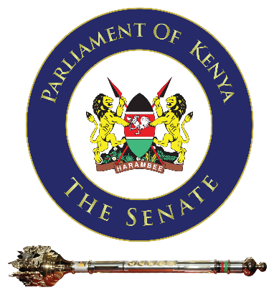

13TH PARLIAMENT
FOURTH SESSION

REPORT OF THE PLANNING COMMITTEE FOR THE SITTINGS OF THE SENATE IN BUSIA COUNTY
6TH TO 10TH OCTOBER, 2025
(SENATE MASHINANI)

Clerk’s Chambers
The Senate
Parliament Buildings
NAIROBI NOVEMBER, 2025

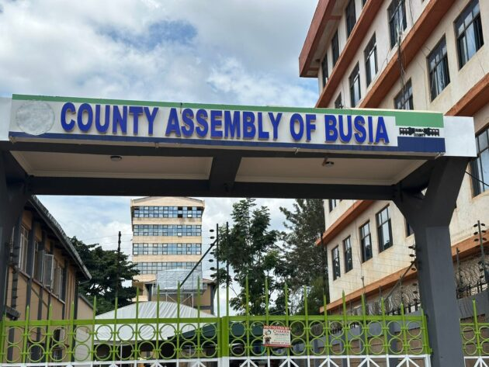
Main Entrance of the County Assembly of Busia, where the Sittings of the Senate took place from 6th – 10th October, 2025

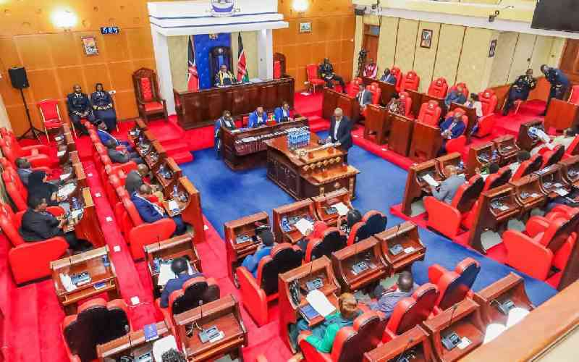

Inside the chamber of the County Assembly of Busia, during a Plenary Session

TABLE OF CONTENTS

CHAPTER 1 .............................................................................................. 5

INTRODUCTION ............................................................................................. 5

CHAPTER 2 .............................................................................................. 8

BUSINESS CONSIDERED BY SENATE IN PLENARY ……………………………..... 8

CHAPTER 3 ............................................................................................. 20

COMMITTEE BUSINESS ............................................................................... 20

1) Standing Committee on Justice, Legal Affairs, and Human Rights Committee 22

2) Standing Committee on Education ................................................................ 25

3) Standing Committee on Trade, Industrialization and Tourism ....................... 28

4) Standing Committee on National Cohesion, Equal Opportunity, and Regional

Integration…………………….…..…..…..…..…..…..…..………………………………. 31

5) Standing Committee on Agriculture, Livestock and Fisheries ......................... 35

6) Standing Committee on Finance and Budget ….…..…..…..…..…..…..…..…..…. 40

7) Standing Committee on Health ……………..………….…..…..…..…..…..…..……. 42

8) Standing Committee on National Security, Defence and Foreign Relations …. 45

9) Select Committee on County Public Accounts ................................................ 46

CHAPTER 4 ............................................................................................. 51

CHAMBER, OFFICES AND COMMITTEE ROOMS ......................................... 51

CHAPTER 5 ............................................................................................. 55

MEDIA AND BROADCASTING OF SENATE PROCEEDINGS ................................. 55
SENATE EXHIBITION FOR CIVIC AWARENESS ................................................... 58

CHAPTER 6 ............................................................................................. 64
CORPORATE SOCIAL RESPONSIBILITY (CSR) BY KEWOSA ................................ 64
FOOTBALL MATCHES …………………………………………………………………..……. 70

CHAPTER 7 ............................................................................................. 74
SECURITY .......................................................................................................... 74

CHAPTER 8 .............................................................................................. 77
HOSPITALITY ..................................................................................................... 77

CHAPTER 9 .............................................................................................. 83
TRANSPORT TO AND FROM BUSIA ………………..……………………………………… 83

CHAPTER 10 ............................................................................................ 85
ACCOMMODATION ........................................................................................... 85 EXPENDITURE STATUS OF SENATE MASHINANI IN BUSIA COUNTY …….... 85

SUCCESSES FROM THE SENATE SITTINGS IN BUSIA COUNTY ……….…….. 87

OTHER SUCCESSES …………………………………………………………………..…... 88

CHALLENGES FROM THE SENATE SITTINGS IN BUSIA …..….……..……..... 89

FINAL RECOMMENDATIONS .................................................................…. 89

ANNEXURES ............................................................................................. 91

CHAPTER 1

INTRODUCTION

Article 126 (1) of the Constitution of Kenya provides that a sitting of either House of Parliament may be held at any place within Kenya and may commence at any time that the House appoints.

It is in line with this provision of the Constitution that on 11th July, 2024, through a Motion, the Senate resolved to hold its Plenary and Committee sittings in Busia County, from 23rd to 27th September, 2024.

To prepare and actualize the resolution of the Senate, the Clerk of the Senate vide a Memo dated 12th July, 2024 constituted a Planning Committee comprising-

No. | Name | Designation
 | Mr. Zakayo Mogere | Deputy Director, Legislative & Procedural Services
 | Ms. Josephine Kusinyi | Deputy Director, Legal Services
 | Dr. Brenda Ogembo | Principal Clerk Assistant I
 | Mr. Maricus Agutu | Principal Research Officer
 | Ms. Rachael Nakitare | Technical Manager, PBU
 | Ms. Caroline Cheruiyot | Principal Legal Counsel II
 | Mr. Charles Ngatia | Principal Clerk Assistant II
 | Mr. Innocent Mbaya | Principal Clerk Assistant II
 | Mr. Joseph Mwangi | Principal Clerk Assistant II
 | Ms. Kavata Musyoka | Principal Clerk Assistant II
 | Ms. Angela Macharia | Senior Clerk Assistant
 | Mr. Daniel Kirwa | Senior Sergeant-At-Arms II
 | Ms. Concepta Owino | Hansard Reporter I
 | Ms. Ann Opola | Legal Counsel II
 | Ms. Njeri Manga | Media Relations Officer II
 | Mr. Erick Nyaga | Public Communications Officer II
 | Mr. Hassan Muhsin | Procurement Officer II
 | Mr. Julius Maganga | Accountant II
 | Ms. Florence Komoltochok | Senior Food & Beverage
 | Mr. Tony Kinyua | Electrical Engineer
 | Mr. Kenneth Opondi | Senior ICT Assistant
 | Mr. Ian Otieno | Audio Assistant
 | Mr. Eric Kipng'eno | Personal Secretary (Secretariat)
 | Ms. Belinda Barasa | Clerk Assistant III (Secretariat)
 | Ms. Tiffany Kiarie | Clerk Assistant III (Secretariat)
 | Mr. Hussein Ali | Office Assistant (Secretariat)

The Senate Planning Committee, considered the need for additional technical officers in various fields to undertake a detailed site visit to Busia County, in a bid to set the infrastructure required, identify the gaps and recommend solutions for a seamless operation during the sittings. The team comprised of the following members –

No. | Name | Designation
 | Ms. Doris Gitonga | PBU Producer
 | Ms. Bartecey Ayiro | Superintendent Mechanical
 | Mr. Stephen Musau | Senior Charge-hand
 | Mr. Morris Mwiti | Inspector I - Buildings
 | Mr. Patrick Siele | Inspector II - Mechanical
 | Mr. Dahir Gudow | Inspector II - Electrical
 | Ms. Sarah Rukwaro | Serjeant-At-Arms II
 | Mr. Richard Njoroge | Audio Officer
 | Mr. Polycarp Mbori | Chef Departie

The Committee alongside the technical officers, were tasked with the responsibility of organizing, planning and facilitating the necessary logistics to enable the Senate to sit in Busia County. The Committee held a total of nine (9) meetings and two reconnaissance visits to Busia County; one by the Planning Committee and Technical officers and the other by the Senate Board of Management on 25th – 27th July, 2024 and 11th – 14th August, 2024 respectively.

However, due to budgetary constraints, the Senate Business Committee during its meeting held on 24th September, 2024, further resolved to defer the sittings of the Senate in Busia County until the next financial year.

The Senate on Tuesday, 29th July, 2025 considered a Motion on Approval of Sittings of the Senate to be held in Busia County and resolved to hold its Plenary and Committee sittings in Busia County, from 6th to 10th October, 2025.

As the Committee that was constituted on 12th July, 2024 had already made progress in spearheading the preparations for the Senate Sittings in Busia County, they were best placed to continue planning, with only one change being the replacement of Ms. Rachael Nakitare who exited the Parliamentary Service Commission with Mr. Evans Ombati, of Parliamentary Broadcasting Unit.

The Committee alongside the technical officers, were tasked with the responsibility of organizing, planning and facilitating the necessary logistics to enable the Senate to sit in Busia County. The Committee held a total of six (6) meetings and two reconnaissance visits to Busia County; one by the Planning Committee and Technical officers and the other by the Senate Board of Management on 3rd – 6th August, 2025 and 6th – 10th October, 2025 respectively.

CHAPTER 2

BUSINESS CONSIDERED BY SENATE IN PLENARY

The Senate held 4 Plenary Sittings: on Tuesday 7th, Wednesday 8th (morning and afternoon) and Thursday, 9th October, 2025. The highlights of the Plenary sittings are as follows-

Messages

The following Message was conveyed by the Speaker of the Senate-

Message from the National Assembly on the passage, by the National Assembly of the County Governments Additional Allocations (No.2) Bill (Senate Bills No. 8 of 2025).

Papers

The following Papers were laid on the Table of the Senate-

- Report of the Commission on Revenue Allocation on own source revenue potential and tax gap study of County Governments.

(Tabled by the Senate Majority Leader)

- Report of the Standing Committee on Devolution and Intergovernmental Relations on its inquiry into commercial bank accounts opened and operated by County Governments.

(Tabled by the Chairperson, Standing Committee on Devolution and Intergovernmental Relations)

- Report of the Standing Committee on Land, Environment and Natural Resources on a Petition to the Senate by Mr. William Kaguro Michael regarding the Changara Water Pan, A World Bank Funded Project in Busia County.

- Report of the Standing Committee on Land, Environment and Natural Resources on a Petition to the Senate by Mr. Francis Wainaina Njuguna Mbogo Concerning historical injustices and illegal alienation of L.R. No. 7153/1, 7153/2, 7153/R, also known as L.R. No. 12825 in Kiambu County.

- Report of the Standing Committee on Land, Environment and Natural Resources on a Petition to the Senate by Mr. James Mwaura Njoroge and other Nyandarua Internally Displaced Persons (IDPs) concerning delayed compensation and occupation of parcels of land.

- Report of the Standing Committee on Land, Environment and Natural Resources on a Petition to the Senate by Wananchi Self-Help Group regarding land ownership dispute of the Wananchi Settlement Scheme in Mwatate Constituency in Taita Taveta County.

- Report of the Standing Committee on Land, Environment and Natural Resources on a Petition to the Senate by Mr. Peter Kangwaru Nyaga regarding the plight of the landless in Muthanthara, Embu County.

- Report of the Standing Committee on Land, Environment and Natural Resources on a Petition to the Senate by Mr. Robin Kalama and other residents of Marungu in Taita Taveta County, concerning threatened eviction from their ancestral land by Holy Rosary Catholic Parish, Mwanda.

- Report of the Standing Committee on Land, Environment and Natural Resources on a Petition to the Senate by representatives of Mwabundusi Land Squatters in Bobaracho Ward, in Kisii County concerning delayed allocation of alternative land by way of re-settlement or compensation for the ancestral land that was alienated by the government of Kenya for creation of the Kisii Agricultural Institute and Kisii Farmers Training Center.

- Report of the Standing Committee on Land, Environment and Natural Resources on a Petition to the Senate by Mr. Nagib Shamsan and others concerning recognition of land ownership rights and redress of historical injustices in Mombasa County.

(Tabled by the Chairperson, Standing Committee on Land, Environment and Natural Resources)

- The National Treasury and Economic Planning Annual Public Debt Management report for 2024/2025.

(Tabled by the Senate Majority Leader)

- Report of the Kenya Parliamentary Delegation to the 150th Assembly of the Inter-Parliamentary Union (IPU) and Related Meetings held in Tashkent, Uzbeskistan from 5th to 9th April, 2025.

(Tabled by Sen. Catherine Mumma, MP)

Notices of Motion

The following Notices of Motion were given-

- Consideration of the Report of the Standing Committee on Land, Environment and Natural Resources on a Petition to the Senate by Mr. William Kaguro Michael regarding the Changara Water Pan, A World Bank Funded Project in Busia County.
- Consideration of the Report of the Standing Committee on Land, Environment and Natural Resources on a Petition to the Senate by Mr. Francis Wainaina Njuguna Mbogo Concerning historical injustices and illegal alienation of L.R. No. 7153/1, 7153/2, 7153/R, also known as L.R. No. 12825 in Kiambu County.

- Consideration of the Report of the Standing Committee on Land, Environment and Natural Resources on a Petition to the Senate by Mr. James Mwaura Njoroge and other Nyandarua Internally Displaced Persons (IDPs) concerning delayed compensation and occupation of parcels of land.

- Consideration of the Report of the Standing Committee on Land, Environment and Natural Resources on a Petition to the Senate by Wananchi Self-Help Group regarding land ownership dispute of the Wananchi Settlement Scheme in Mwatate Constituency in Taita Taveta County.

- Consideration of the Report of the Standing Committee on Land, Environment and Natural Resources on a Petition to the Senate by Mr. Peter Kangwaru Nyaga regarding the plight of the landless in Muthanthara, Embu County.

- Consideration of the Report of the Standing Committee on Land, Environment and Natural Resources on a Petition to the Senate by Mr. Robin Kalama and other residents of Marungu in Taita Taveta County, concerning threatened eviction from their ancestral land by Holy Rosary Catholic Parish, Mwanda.

- Consideration of the Report of the Standing Committee on Land, Environment and Natural Resources on a Petition to the Senate by representatives of Mwabundusi Land Squatters in Bobaracho Ward, in Kisii County concerning delayed allocation of alternative land by way of re-settlement or compensation for the ancestral land that was alienated by the government of Kenya for creation of the Kisii Agricultural Institute and Kisii Farmers Training Center.

- Consideration of the Report of the Standing Committee on Land, Environment and Natural Resources on a Petition to the Senate by Mr. Nagib Shamsan and others concerning recognition of land ownership rights and redress of historical injustices in Mombasa County.

(Given by the Chairperson, Standing Committee on Land, Environment and Natural Resources)

- Addressing systemic challenges at the Busia and Malaba Border Posts to enhance Kenya's competitiveness and regional integration.

(Given by the Senate Majority Leader)
- Report of the Kenya Parliamentary Delegation to the 150th Assembly of the Inter-Parliamentary Union (IPU) and Related Meetings held in Tashkent, Uzbekistan from 5th to 9th April, 2025.

(Given by Sen. Catherine Mumma, MP)
Questions

The Cabinet Secretaries for Agriculture and Livestock Development, and for Interior and National Administration, submitted written apologies indicating their unavailability to appear before the Senate on Wednesday, 8th October, 2025, to respond to Questions, citing their participation in the 24th Common Market for Eastern and Southern Africa (COMESA) Summit in Nairobi.

The Senate Business Committee, at its meeting held on Tuesday, 7th October, 2025, approved the requests, and consequently, no Questions were scheduled for the morning sitting of Wednesday, 8th October, 2025.

Statements

The following Statements were made and/or sought-

Pursuant to Standing Order 52(1)

- The Senator for Nairobi City County (Sen. Edwin Sifuna, MP) on behalf of Nominated Senator (Sen. Crystal Asige, MP) made a statement on the commemoration of Dyslexia Awareness month.

- The Senator for Mombasa County (Sen. Mohamed Faki, MP) made a statement on the ongoing strike by academic staff in public universities.

- Nominated Senator (Sen. Hezena Lemaletian, MP) on behalf of Nominated Senator (Sen. Veronica Maina, MP) made a statement on the rising cases of early teenage pregnancy and sexual and gender-based violence (SGBV) in Busia County.

- The Senator for Nandi County (Sen. Samson Cherarkey, MP) made a statement regarding the untimely demise of the late Elijah Kiptarbei Lagat.

Pursuant to Standing Order 53 (1)

- The Senator for Vihiga County (Sen. Godfrey Osotsi, MP) sought a statement from the Standing Committee on Roads, Transportation and Housing concerning the ongoing forceful eviction of traders at Luanda Market in Vihiga County.

- The Senator for Busia County (Sen. Andrew Omtatah, MP) sought a statement from the Standing Committee on Roads, Transportation and Housing concerning the proposed Lake Victoria Ring Road (LVRR) project.

- The Senator for Busia County (Sen. Andrew Omtatah, MP) sought a statement from the Standing Committee on National Security, Defence and Foreign Relations Concerning the operationalization of the Muluanda Border Point in Samia Sub-County in Busia County.

- The Senator for Busia County (Sen. Andrew Omtatah, MP) sought a Statement from the Standing Committee on Land, Environment and Natural Resources concerning the irregularities surrounding the Busia Green Park Project.

- Nominated Senator (Sen. Miraj Abdillahi, MP) sought a statement from the Standing Committee on Labour and Social Welfare concerning the alarming rise of child labour and the growing number of street children in cities and towns across the country.

- The Senator for Kajiado County (Sen. Seki Ole Kanar, MP) sought a statement from the Standing Committee on Trade, Industrialization and Tourism concerning the proposed sale of shares in East African Portland Cement Plc (EAPC) to Kalahari Cement Limited.

- The Senator for Nairobi County (Sen. Edwin Sifuna, MP) on behalf of Nominated Senator (Sen. Crystal Asige, MP) sought a statement from the Standing Committee on Labour and Social Welfare regarding the unjust charging of medical assessment fees to Persons with Disabilities (PWDS).

- The Senator for Nairobi County (Sen. Edwin Sifuna, MP) on behalf of Nominated Senator (Sen. Crystal Asige, MP) sought a statement from the Standing Committee on Education regarding the status and future of the Kenya School of Revenue Administration (KESRA).

- The Senator for Nandi County (Sen. Samson Cherarkey, MP) sought a statement from the Standing Committee on Justice, Legal Affairs and Human Rights regarding the brutal killing of two (2) people and the use of excessive force by police at Kimwani Area in Tindiret Sub-County, Nandi County.

- The Senator for Murang’a County (Sen. Joe Nyutu, MP) sought a statement from the Standing Committee on Health regarding the implementation of the Health Insurance Programme Dubbed Kang’ata Care in Murang’a County.

- The Senator for Mombasa County (Sen. Mwinyihaji Faki, MP) on behalf of the Senator for Kisumu County (Sen. (Prof.) Tom Ojienda Sc, MP) sought a statement from the Standing Committee on National Security, Defence and Foreign Relations regarding the Ongoing Police Recruitment Exercise.

- The Senator for Busia County (Sen. Andrew Omtatah, MP) sought a statement from the Standing Committee On Land, Environment and Natural Resources concerning the stalled irrigation and water supply projects in Busia County.

- The Senator for Busia County (Sen. Andrew Omtatah, MP) sought a statement from the Standing Committee on Land, Environment and Natural Resources concerning the illegal gold mining activities in Bumutiru in Busia County, Ramula in Siaya County and Rosterman in Kakamega County.

- The Senator for Busia County (Sen. Andrew Omtatah, MP) sought a statement from the Standing Committee on Justice, Legal Affairs and Human Rights concerning the nomination of a female judge to the East African Court of Justice (EACJ).

- The Senator for Marsabit County (Sen. Mohamed Chute, MP) sought a statement from the Standing Committee on National Security, Defence and Foreign Relations regarding the reported abduction of Mr. Jillo Guyo Boru, a 47- year-old laboratory technician attached to Dambala Facana Health Centre in Marsabit County.

- The Senator for Nandi County (Sen. Samson Cherarkey, MP) sought a statement from the Standing Committee on Labour and Social Welfare regarding unfair labour practices and systemic discrimination within I&M Bank, Kenya.

- The Senator for Nandi County (Sen. Samson Cherarkey, MP) sought a statement from the Standing Committee on Finance and Budget regarding the findings of a special audit by the Auditor General on Kenya’s Central Digital Payments Gateway, the e-Citizen.

- The Senator for Marsabit County (Sen. Mohamed Said Chute, MP) sought a statement from the Standing Committee on Health Regarding the non-payment of Community Health Promoters (CHPS) in Marsabit County

- The Senator for Marsabit County (Sen. Mohamed Said Chute, MP) sought a statement from the Standing Committee on Land, Environment and Natural Resources regarding the El Gadhe, Kambinye and Bagasi Borehole Projects in Marsabit County.

- The Senator for Murang’a County (Sen. Joe Nyutu, MP) sought a statement from the Standing Committee on National Security, Defence and Foreign Relations regarding the delay in the issuance and collection of National Identity Cards.

- The Senator for Busia County (Sen. Andrew Omtatah, MP) sought a statement from the Standing Committee on Agriculture, Livestock and Fisheries concerning the protection of Lake Turkana’s fishing ecosystem and the establishment of Busia as a national dry fish auction market.

- The Senator for Busia County (Sen. Andrew Omtatah, MP) sought a statement from the Standing Committee on Land, Environment and Natural Resources regarding the conservation, development and promotion of Kakapel Pre-Historic Site in Busia County.

- The Senator for Busia County (Sen. Andrew Omtatah, MP) sought a statement from the Standing Committee on Agriculture, Livestock and Fisheries regarding the management of sugarcane cess, dilapidated infrastructure and rampant sugarcane smuggling in Busia County.

- Ombi la taarifa kutoka kwa Seneta wa Kaunti ya Mombasa (Sen. Mohammed Faki, Mbunge) kwa Kamati ya Kudumu ya Leba Na Ustawi wa Jamii kuhusu ucheleweshaji wa malipo ya kustaafu ya Bw. Abdall Mohamed Abdalla Ghazal, Jijini Riyadh, Saudi Arabia haikuzingatiwa kutokana na kutokuwepo kwa Seneta.

Bills

The following Bills were debated at Second Reading stage-
- The County Hall of Fame Bill (Senate Bills No. 18 of 2023)
- The County Oversight and Accountability Bill (Senate Bills No. 3 of 2024)

Motions

The following Motions were passed -
- Adoption of the Report of the Standing Committee on Devolution and Intergovernmental Relations on a Petition to the Senate by Mr. Japheth Makokha, the Executive Director of Tripple the Impact CBO to amend the County Governments Act 2012, on the mandate of the County Governors assigning portfolio of a County Executive Committee Member (CECM) to the Deputy County Governors.
- Adoption of the Report of the Standing Committee on Finance and Budget on the County Governments (Equitable Share) Cash Disbursement Schedule for financial Year 2025/2026
- Addressing systemic challenges at the Busia and Malaba Border Posts to enhance Kenya’s competitiveness and regional integration.

Invited Dignitaries

The following dignitaries were invited to attend Plenary sittings of the Senate and those present were seated in the Speaker's gallery-

Governors
- Gov. Paul Otuoma - Busia County
- Gov. Kenneth Lusaka - Bungoma County/former Speaker of the Senate
- Gov. Fernandes Barasa - Kakamega County
- Gov. James Orengo - Siaya County
- Gov. (Dr.) Wilber Otichilo - Vihiga County

Deputy Governors
- H.E. Arthur Odera - Busia County
- H.E. (Pst.) Janepher Chemtai Mbatiany - Bungoma County
- H.E. Wilberforce Kitiezo Gwadoya - Vihiga County
- H.E. Philomena Bineah Kapkory - Trans-Nzoia County

Speakers of County Assemblies
- Hon. Fredrick Odilo - Busia County Assembly
- Hon. Emmanuel Situma - Bungoma County Assembly
- Hon. James Namatsi - Kakamega County Assembly
- Hon. George Okode - Siaya County Assembly
- Hon. Christopher Omulele - Vihiga County Assembly

Deputy Speaker s of County Assemblies
Hon. Ronald Ochalu - Busia County Assembly

Members of the National Assembly from Busia County
- Hon. Geoffrey Odanga - Matayos Constituency
- Hon. Raphael Wanjala - Budalang’i Constituency
- Hon. Wilberforce Oundo - Funyula Constituency
- Hon. Edward Oku Kaunya - Teso North Constituency
- Hon. Joseph Oyula - Butula Constituency
- Hon. Mary Emaase Otucho - Teso South Constituency
- Hon. Geoffrey Mulanya - Nambale Constituency
- Hon. Catherine Omanyo - Woman Representative, Busia County

Clerks of County Assemblies
- Mr. Gabriel Erambo - Acting Clerk of the Busia County Assembly
- Mr. Charles Wafula - Clerk of the Bungoma County Assembly
- Mr. Donald Manyala - Clerk of the Kakamega County Assembly
- Mr. Eric Ogenga - Clerk of the Siaya County Assembly
- Ms. Ambaka Kilinga - Clerk of the Vihiga County Assembly

Recognition of prominent persons from Busia County

The Speaker acknowledged the following persons -

 | His Excellency Hon. Moody Awori, EGH | Former Vice-President of the Republic of Kenya and the first person to serve in that capacity from Busia County
 | Sen. Amos Wako, Egh, SC | A Renowned Jurist, Long-Serving Attorney General of the Republic of Kenya and the first Senator for Busia County. | Present
 | Hon. (Prof.) Julia Ojiambo | A Renowned Politician and Academic. First Female Assistant Minister Appointed to various Portfolios. Party Leader of the Labour Party of Kenya, Member of Parliament for Busia Central Constituency, now known as Funyula Constituency, a Crusader for Affirmative Action and one of the founder members of the Maendeleo ya Wanawake. | Present
 | Hon. Justice (Dr.) Smokin Wanjala, CBS | Renowned Legal Scholar, Judge of the Supreme Court of Kenya and current director of the Kenya Judiciary Academy
 | Hon. Sospeter Ojaamong, MGH | First Governor of Busia County and former Member of Parliament representing Amagoro Constituency
 | Hon. Chrysanthus Okemo, EGH | A Former Member of Parliament for Nambale Constituency; Cabinet Minister in the Ministries of Finance and Energy Respectively; and a Former Member of the Parliamentary Service Commission in the 10th Parliament.
 | Hon. Albert Aggrey Alexander Ekirapa | Former Long-Serving Nation Media Group Chairman and Chief Executive. He Also Served as Member of Parliament for Amagoro Constituency and Assistant Minister for Trade and Industry.
 | Hon. Francis Masakhalia, EGH | First Member of Parliament for Butula Constituency and Former Minister for Finance
 | Hon. Florence Mutua | First Busia County Woman Representative
 | Hon. Ababu Namwamba, EGH | Permanent Representative of the Republic of Kenya to the United Nations Office at Nairobi and the United Nations Environment Programme. Former Member of Parliament for Budalang’i Constituency and Cabinet Secretary in various Portfolios
 | Hon. (Dr.) Christine Mango | A Leading Educationist, Former Member of Parliament for Butula Constituency who also served as a Member of the Judicial Service Commission | Present
 | Hon. Philip Masinde | Former Cabinet Minister for Labour and Member of Parliament for Nambale Constituency | Present
 | Hon. (Dr.) John Sakwa Bunyasi | Former Member of Parliament for Nambale Constituency and current Chairman of the Kenya Development Corporation | Present
 | Ms. Susan Mang’eni, CBS | Principal Secretary, State Department of Micro, Small, and Medium Enterprises, Ministry of Cooperatives, and Micro, Small, and Medium Enterprises Development
 | Dr. Boniface Makokha | Principal Secretary, State Department of Economic Planning in the National Treasury and Economic Planning | Present
 | Dr. Josephine Ojiambo | Seasoned Diplomat who has distinguished herself as one of Kenya’s premier multilateralists. she is recognized by the Ministry of Health as the National Sickle Cell Champion
 | Hon. Justice Rtd. Mathew Emukule | Former Judge of the High Court of Kenya and a distinguished jurist
 | Dr. Joseph Jesse (JJ) Masiga | Legendary Footballer who starred as a Striker for AFC Leopards and Harambee Stars
 | Mr. Mcdonald Mariga | Renowned International Professional Footballer for Harambee Stars and First Kenyan to play in and win the UEFA Champions League with Inter Milan. He Serves as the Current Vice-Chairperson of FKF
 | Mr. Gabriel Mukele | Former Vice Chairman of the Electoral Commission of Kenya (ECK), the Predecessor to the Independent Electoral and Boundaries Commission (IEBC) | Present
 | Mr. Vincent Ongidi | Celebrated Musician Renowned for His Vibrant Renditions of Traditional Music most notably the “Mama Mulayi” hit Song. | Present
 | Mr. Victor Wanyama | Celebrated Footballer and Captain of Harambee Stars and the First Kenyan to play in the English Premier League and Score in the UEFA Champions League
 | Mr. Wilberforce Mulamba | Legendary attacking Midfielder, best known for his sensational dribbling skills and prolific goal-scoring and his long service in AFC Leopards and Harambee Stars

The Speaker issued a posthumous acknowledgement for the following -

 | The Late Hillary Ng’weno | Nuclear Physicist, who was a Career Journalist, best known as the Editor-In-Chief of the Weekly Review. He founded the first independent Television News Station in Kenya, STV
 | The Late Prof. Nimrod Bwibo | A Renowned Paediatrician and Academic and Former Chairman of the Maseno University Council. He was one of the founding members of the University of Nairobi Faculty of Medicine
 | The Late Prof. Nelson Awori | A Widely Celebrated Medical Doctor, Educator and Researcher. He was the first african doctor to perform a kidney transplant in 1978. He also pioneered the Department of Urology at the University of Nairobi
 | The Late Hon. James Charles Osogo | Veteran Politician and long Serving Cabinet Minister in many Portfolios

Groups which visited and observed at Plenary Sitting

The following groups visited and observed Plenary Sittings of the Senate-
- Teachers and students from Alupe University in Busia County
- Teachers and students from Busia Township Primary School
- Religious Leaders of the Busia County Interfaith Network
- Teachers and students from St. Monica Chakol Girls’ High School in Busia County

CHAPTER 3

COMMITTEE BUSINESS
During the Sittings of the Senate in Busia County, nine (9) Committees held meetings and conducted site or inspection visits as outlined in this section.
Monday, 5th October, 2025
- The Standing Committee on Justice, Legal Affairs and Human Rights held a town hall meeting to receive submissions from members of the public on the Constitution of Kenya (Amendment) Bill, 2025 (Senate Bills No. 13 of 2025).
Tuesday, 6th October, 2025
- The Standing Committee on Education held a meeting with the Governor of Busia County to deliberate on the status of Early Childhood Development Education (ECDE) and County Vocational Education and Training in the County.
- The Standing Committee on Trade, Industrialization and Tourism conducted the following visits:
  - Malaba One Stop Border Post to inspect the facilitation of cross-border trade;
  - Kakapel Pre-Historic Site; and
  - Ng’alechom (Ape Sanctuary).
- The Standing Committee on National Cohesion, Equal Opportunity and Regional Integration held a meeting with Kenya Revenue Authority and Immigration Department at the Busia One Stop Border Post for a follow up meeting on implementation of cross border integration measures.
- The Standing Committee on Agriculture, Livestock and Fisheries held a meeting with the Sectoral Committee on Agriculture, Livestock, Fisheries and Blue Economy to assess cross-border trade issues affecting food security and livelihoods.
- The County Public Accounts Committee (CPAC) held a meeting with the Governor of Busia County to interrogate Reports of the Auditor-General for Busia County Executive for Financial Year 2023/2024.
Wednesday, 7th October, 2025
No Committee meetings were held, as the Senate conducted plenary sittings in both the morning and afternoon sessions.
Thursday, 8th October, 2025
- The Standing Committee on Agriculture, Livestock and Fisheries conducted inspection visits to:
  - The National Cereals and Produce Board (NCPB) Depot to assess grain reserve capacity; and
  - West Kenya Sugar Factory to evaluate the milling capacity of the plant.
- The Standing Committee on Education conducted county visits to inspect ECDE Centres and Vocational Training Centres in Busia County.
- The Standing Committee on National Cohesion, Equal Opportunity and Regional Integration conducted an inspection visit to the Malabba One Stop Border Post for a follow-up meeting with the Kenya Revenue Authority and the Immigration Department on the implementation of cross-border integration measures, following an earlier engagement held on 3rd May, 2025.
- The Standing Committee on Finance and Budget met with the Governor of Busia County to deliberate on the status of pending bills in the County.
- The Standing Committee on County Public Accounts held a meeting with the Busia County Assembly to consider the Auditor-General’s Report for the County Assembly for the Financial Year 2023/2024, followed by inspection visits to selected County projects referenced in the Report.
- The Standing Committee on Trade, Industrialization and Tourism undertook visits to:
  - Busia One Stop Border Post to inspect the process of facilitating trade in and out the country; and
  - Busia County Aggregated Industrial Park to assess its compliance with standards required to attract additional funding.
- The Standing Committee on National Security, Defence and Foreign Relations held a with the Cabinet Secretary for Interior and National Administration to deliberate on matters relating to police recruitment.
- The Standing Committee on Health conducted an inspection visit to the Busia County Referral Hospital.

Collaboration and Capacity Building
Throughout the week, officers serving in Senate Committees were joined by the secretariats of counterpart Committees from the County Assembly of Turkana for hands-on learning, exchange, and experience sharing.
The detailed reports and findings of each Committee are presented in the sections that follow.

  - STANDING COMMITTEE ON JUSTICE, LEGAL AFFAIRS AND HUMAN RIGHTS;

- TOWNHALL MEETING TO RECEIVE SUBMISSIONS FROM THE PUBLIC ON THE CONSTITUTION OF KENYA (AMENDMENT) BILL (SENATE BILLS NO. 13 OF 2025)

The Standing Committee on Justice, Legal Affairs and Human Rights, established under Standing Order 228(1) of the Senate Standing Orders, is mandated to consider all matters relating to constitutional affairs, the organization and administration of law and justice, elections, promotion of principles of leadership, ethics and integrity, agreements, treaties and conventions, and the implementation of the constitutional provisions on human rights.

The Constitution of Kenya (Amendment) Bill (Senate Bills No. 13 of 2025) was published on 22nd July, 2025, and read a First Time in the Senate on Thursday, 7th August, 2025. Upon First Reading, the Bill was committed to the Standing Committee on Justice, Legal Affairs and Human Rights for consideration and facilitation of public participation.

Pursuant to Article 118 of the Constitution, Parliament is obligated to facilitate public participation and involvement in its legislative and other business. Further, Article 256(2) of the Constitution requires Parliament to publicize any Bill seeking to amend the Constitution and facilitate public discussion on the same.

Given the scope and significance of the Bill, which touches on the bicameral system, public finance, devolution, and legislative procedures, the Committee recognized the importance of conducting a robust and legally sound public participation process. Consequently, the Committee, in consultation with the Senate Business Committee, resolved that public participation be conducted across all forty-seven counties.

With the Senate Mashinani sittings scheduled to take place in Busia County from 6th to 10th October, 2025, Busia was identified as the first county where public hearings on the Bill would be conducted. It was therefore agreed that a town hall meeting be held at the Busia Agricultural Training Centre on Monday, 6th October, 2025.

The town hall meeting was convened at the Busia Agricultural Training Centre and attended by the following Senators:

- Sen. David Wafula Wakoli, MP (Session Chair)
- Sen. (Dr.) Boni Khawale, CBS, MP
- Sen. Julius Murgir Recha, CBS, MP
- Sen. Richard Momoima Onyonka, MP
- Sen. Alexander Munyi Mundigi, MP

Approximately three hundred and forty-one (341) members of the public attended the session. The Secretariat guided participants through the key provisions and objectives of the Bill in both English and Kiswahili. Thereafter, about thirty (30) members of the public presented oral submissions, while others were encouraged to submit their views in writing through Public Views Forms or by sending memoranda via designated email channels.

At the conclusion of the session, the Senators present, led by Sen. David Wafula Wakoli, MP, expressed appreciation to the members of the public for their active participation and reaffirmed the Senate’s commitment to conduct similar hearings in the remaining forty-six counties to ensure broad-based public engagement on the Bill.

Annex: Pictorials
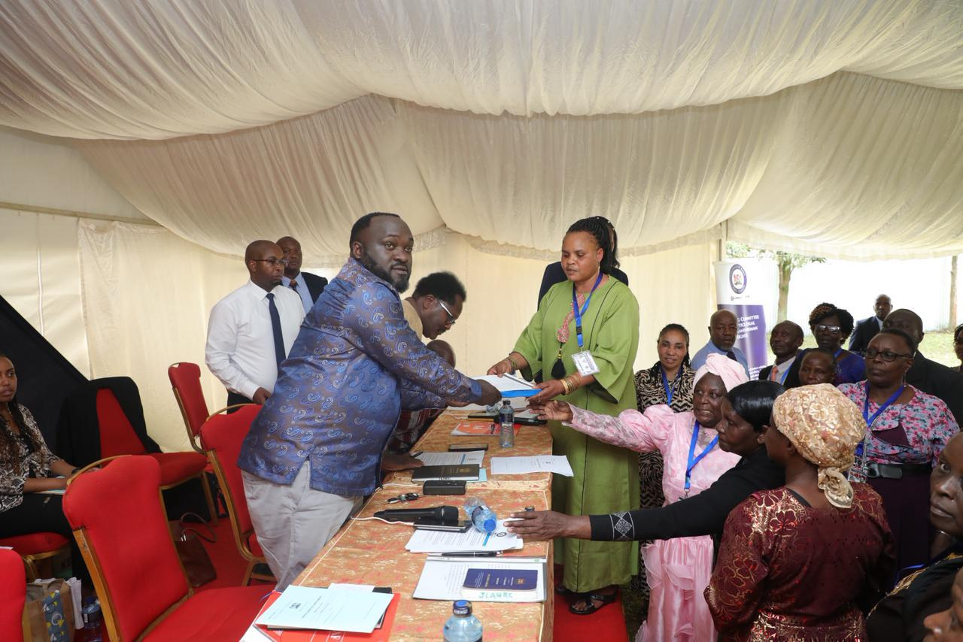
Sen. David Wakoli, MP receiving written submissions from members of the public

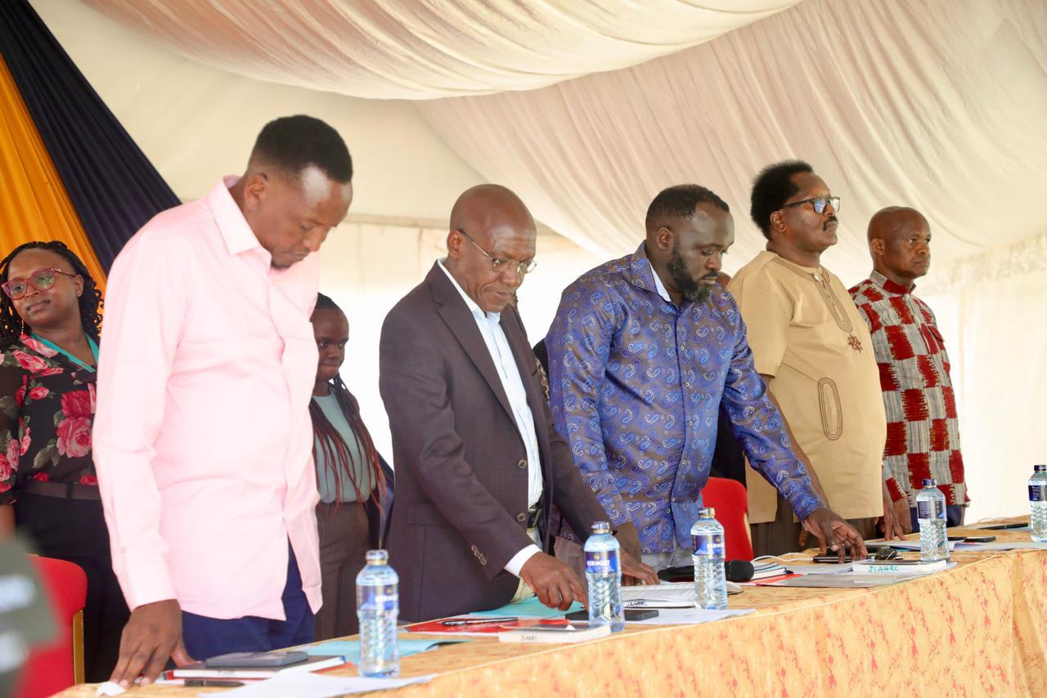
Senators, led by Sen. David Wakoli, MP, presiding over the townhall meeting

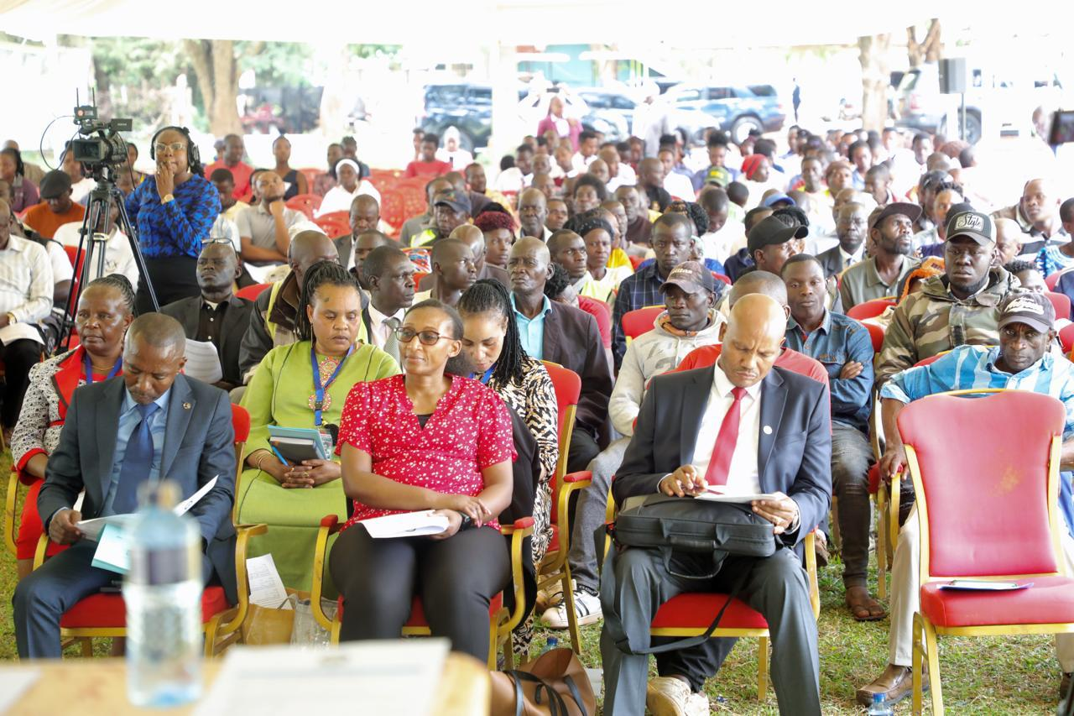
Members of the public following the public hearing proceedings

  - STANDING COMMITTEE ON EDUCATION

On Tuesday, 7th October, 2025, the Standing Committee on Education held a meeting with the Governor of Busia County to deliberate on the status of Early Childhood Development Education (ECDE) and County Vocational Education and Training (VTC) in the County. The discussions focused on the progress made in the establishment and improvement of ECDE centres and vocational training institutions, as well as the challenges facing these sectors in terms of funding, staffing, and infrastructure.

On Thursday, 9th October, 2025, the Committee conducted inspection visits to several learning institutions within Busia County, namely:
- Nambale Vocational Training Centre (VTC);
- Magnet ECDE Centre;
- Okisimo Vocational Training Centre (VTC); and
- Manyole ECDE Centre.

During the visits, the Committee observed that the County Government of Busia had not constructed any ECDE centre since the inception of County Governments in 2013. It was noted that ECDE learners continued to occupy classrooms allocated to them within existing primary schools, which limited the availability of appropriate learning spaces and facilities tailored to early childhood education.

Following these observations, the Committee directed the Governor to resubmit documentation detailing the status of implementation of the construction of ECDE centres in the County, with a view to addressing the identified gaps and improving learning conditions for ECDE learners.

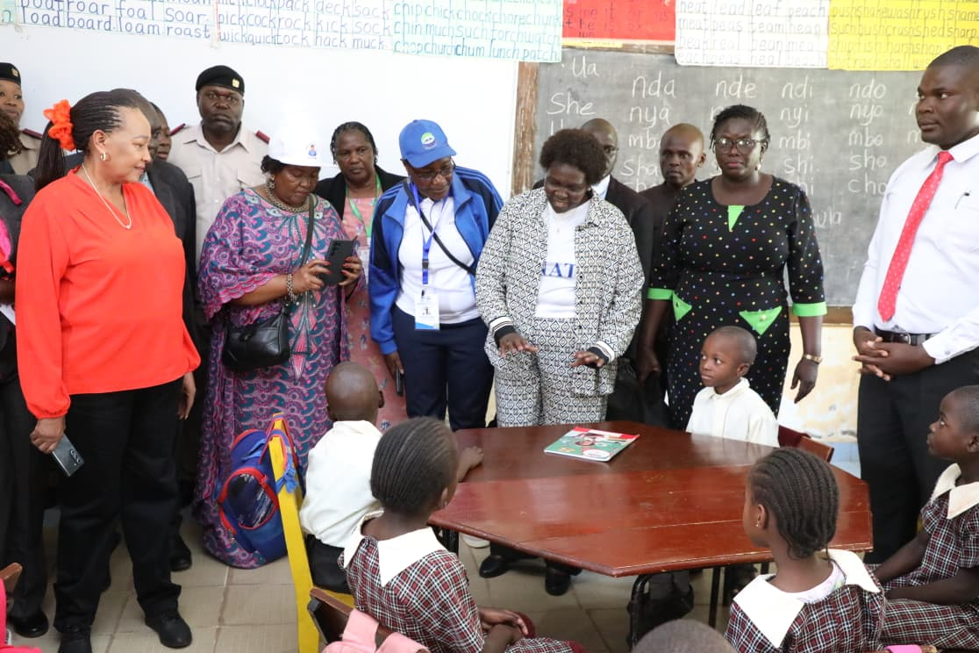
Committee inspection visit to Magnet ECDE Centre

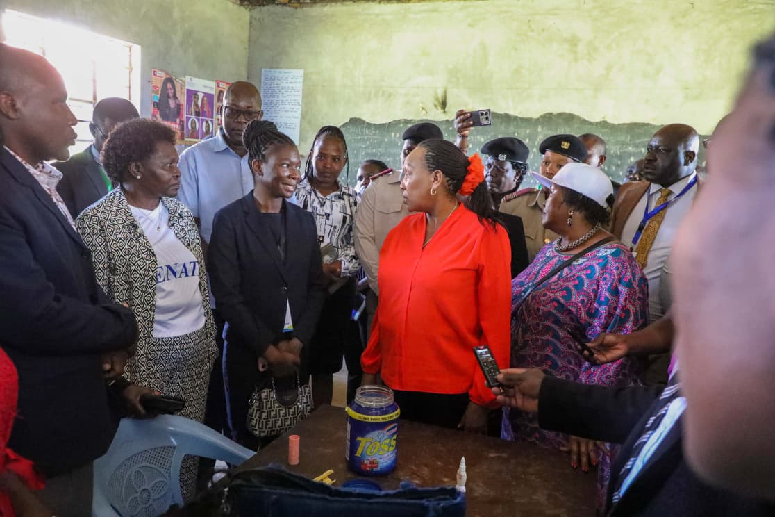
Inspection visit to Nambale VTC

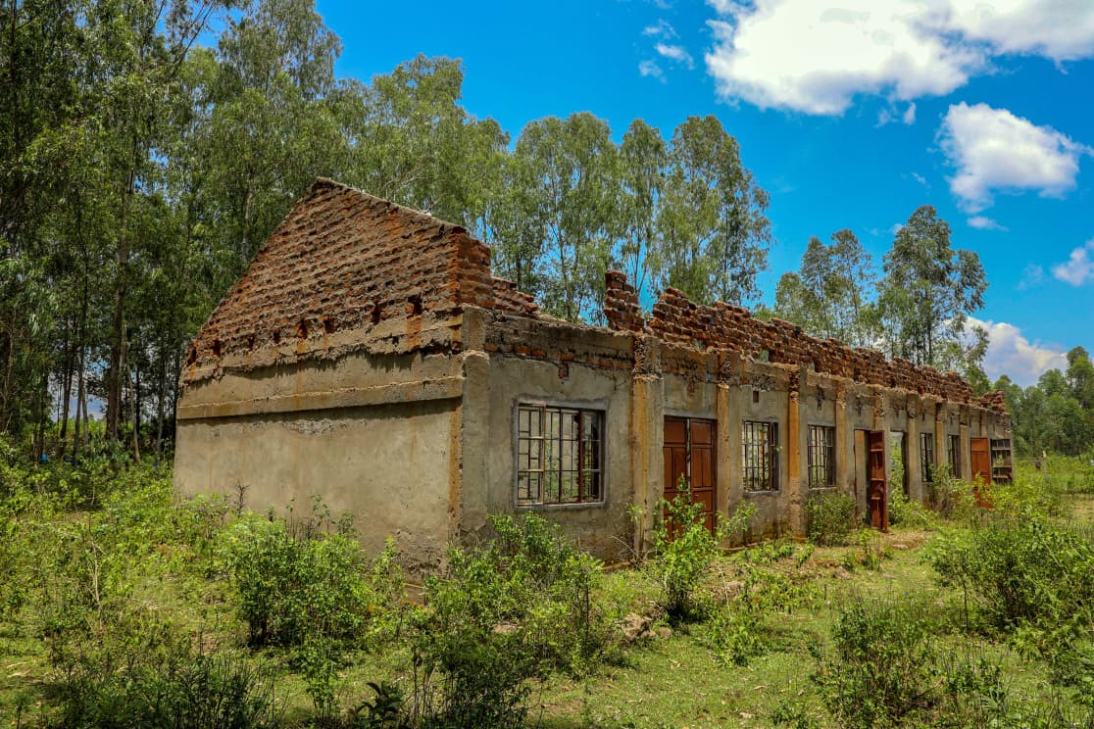
Okisimo VTC which had challenges in completion and had not had students since 2022.

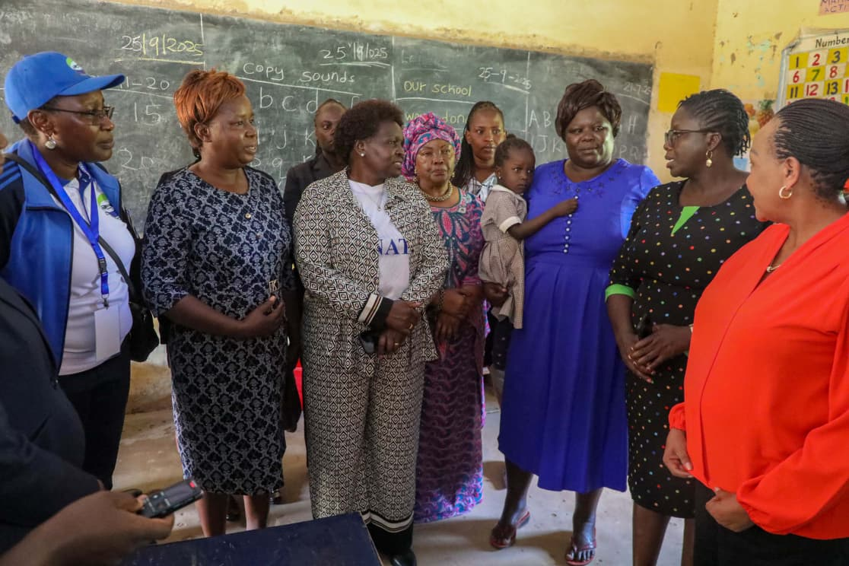
Committee visit to Manyole ECDE centre (the classroom was constructed using NG- CDF)

  - STANDING COMMITTEE ON TRADE, INDUSTRIALIZATION AND TOURISM

The Standing Committee on Trade, Industrialization and Tourism, established under Standing Order 228(1) of the Senate Standing Orders, is mandated to consider all matters relating to trade, industrialization, tourism, cooperatives, investment and divestiture policies.

The Standing Committee on Trade, Industrialization and Tourism visited the following areas-
- Malaba One Stop Border Stop
- Busia One Stop Border Stop
- County Aggregated Industrial Park; and
- Ngelechom pre-historic Site

- VISIT TO BUSIA AND MALABA ONE STOP BORDER POST

The Committee made the following resolutions—

The National Treasury; the Ministry of Trade, Industry and Cooperatives; and the Ministry of East African Community (EAC), the Arid and Semi-Arid Lands (ASALs) and Regional Development, in collaboration with the Kenya Revenue Authority (KRA) and the Kenya National Highways Authority (KeNHA), were directed to develop and present a comprehensive action plan within 90 days to address infrastructure and operational challenges at the Busia and Malaba border posts:

- KeNHA and KRA to fast-track the expansion of access roads, increase the number of cargo scanners, and establish dedicated clearance lanes for perishables and transit cargo to ease congestion.
- The Ministry of Trade, Industry and Cooperatives and the Ministry of EAC, ASALs and Regional Development to enhance bilateral and EAC-level engagements to fully implement and harmonize the One Stop Border Post (OSBP) operations.
- The Ministry of Roads and Transport and KeNHA to prioritize completion of supporting road and rail infrastructure, including dualing the Malaba–interior highway, to prevent domestic logistical bottlenecks.

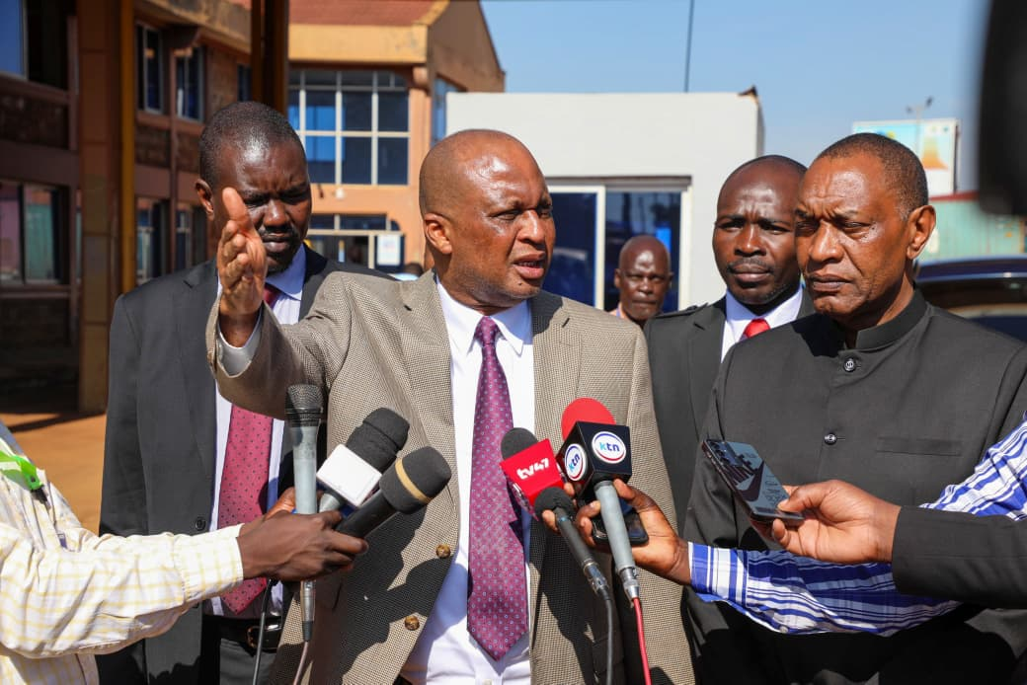
The Committee visit to Busia One stop Border Post
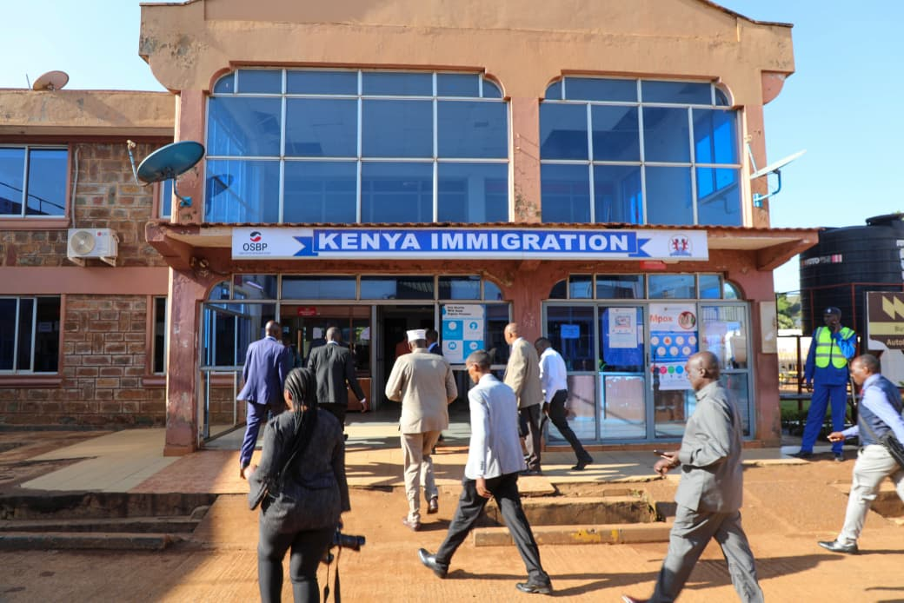

- VISIT TO THE COUNTY AGGREGATED INDUSTRIAL PARK, NASEWA

The Committee visited the County Aggregated Industrial Park (CAIP) at Nasewa and resolved as follows—
- The project completion deadline be extended to 31st December 2025 (initially August 2025).
- All labourers be paid their three-month salary arrears within seven (7) days from 9th October 2025.
- The County Government to submit a feasibility study on the project.
- The National and County Governments to ensure the access road to the park is tarmacked.

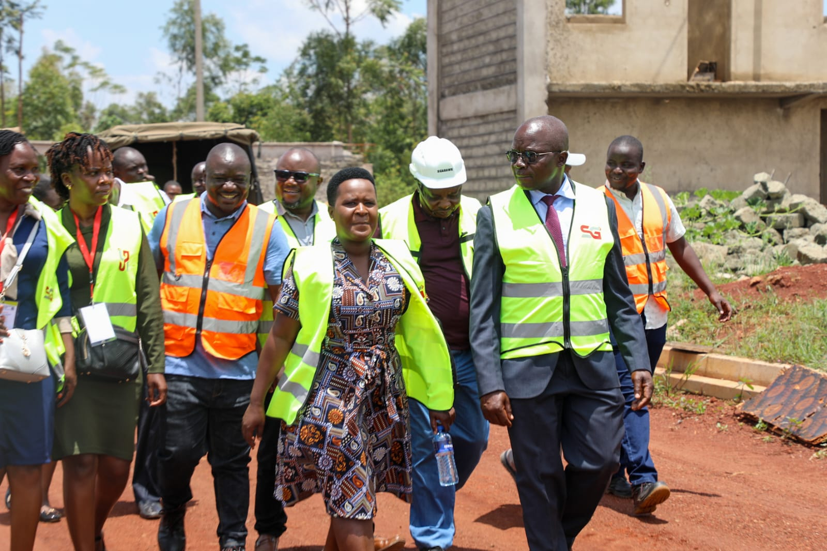
Committee visit to the County Aggregated Industrial Park (CAIP) at Nasewa

- VISIT TO NGELECHOM PRE-HISTORIC SITE

The Committee visited the Ngelechom Pre-Historic Site and resolved as follows—
- The curator to submit a report on the site’s operations and expenditure; and
- The Ministry of Tourism and Wildlife to include the Ngelechom Pre-Historic Site as part of the Western Tourism Circuit.

  - STANDING COMMITTEE ON NATIONAL COHESION, EQUAL OPPORTUNITY, AND REGIONAL INTEGRATION COMMITTEE

The Senate Standing Committee on National Cohesion, Equal Opportunity and Regional Integration is established pursuant to Standing Order 228(1) of the Senate Standing Orders. The Committee is mandated to consider all matters relating to the pursuit of national and inter-community cohesion, equalization of opportunities and improvement in the quality of life and status of all persons, regional integration, the East African Legislative Assembly (EALA), and the Pan African Parliament (PAP).

Pursuant to its mandate to promote regional integration and improve the efficiency of cross-border operations, the Committee conducted an inspection visit to the Busia One Stop Border Post (OSBP) on 7th October 2025, during the Senate Mashinani sittings held in Busia County.

Objectives of the Visit
The objectives of the visit were to:

- To follow up on the progress made from a previous meeting held by the Committee at the Busia One Stop Border Post.
- To establish the reason for delays and inefficiencies at the Busia One Stop Border Post;
- To address corruption reported at Busia Border Post and measures put in place to ensure accountability;
- How the Ministry of East African Community, the ASALs and Regional Development works with relevant agencies to eliminate non-tariff barriers and how the Ministry was enhancing border security while facilitating smooth trade flows and protecting traders from crime, smuggling networks and harassment.
Key Findings
The Committee was apprised on progress made since its last visit in May 2025, and noted as follows:

- An Integrity Committee had been established to promote accountability and transparency in border operations. The Committee meets quarterly and had already convened once in the first quarter of the 2025/2026 Financial Year, during which an action plan on promoting regional integration was developed.
- The Border Management Committee (BMC) had installed an Integrity Suggestion Box to enable members of the public to provide feedback on service delivery.
- The County Government of Busia had been incorporated into border stakeholder management and now participates in quarterly Joint Border Operations Committee meetings. The Committee noted that the County Government had previously been excluded from border management affairs.

The Committee also made the following resolutions from the said meeting:

Following the deliberations, the Committee resolved to convene a joint meeting with the Ministry of Interior and National Administration, the Ministry of East African Community, the ASALs and Regional Development, and the Kenya Revenue Authority (KRA) to address the following issues:
- Upgrade Border Infrastructure: Fast-track road improvements, yard expansion, and ensure accessibility for PWDs.
- Strengthen Staffing and Services: Recruit additional border and health personnel, establish a fully equipped health facility with ambulance and isolation centre, and enhance staff welfare including housing and security.
- Improve Systems and Equipment: Invest in backup power and ICT systems, modern scanners, inspection tools, and enhanced laboratory capacity.
- Ensure Free Public Services: Reclaim management of sanitary facilities at Busia Border Post and provide services free of charge.
- Enhance Coordination and Security: Allocate resources for comprehensive surveillance and strengthen inter-agency coordination for prompt response to operational challenges.

The Committee had scheduled a visit to the Malaba One Stop Border Post on Thursday, 9th October 2025. However, the visit was deferred as the Standing Committee on Trade, Investment and Tourism had already undertaken a similar inspection of the facility on Tuesday, 7th October 2025.

Pictures:
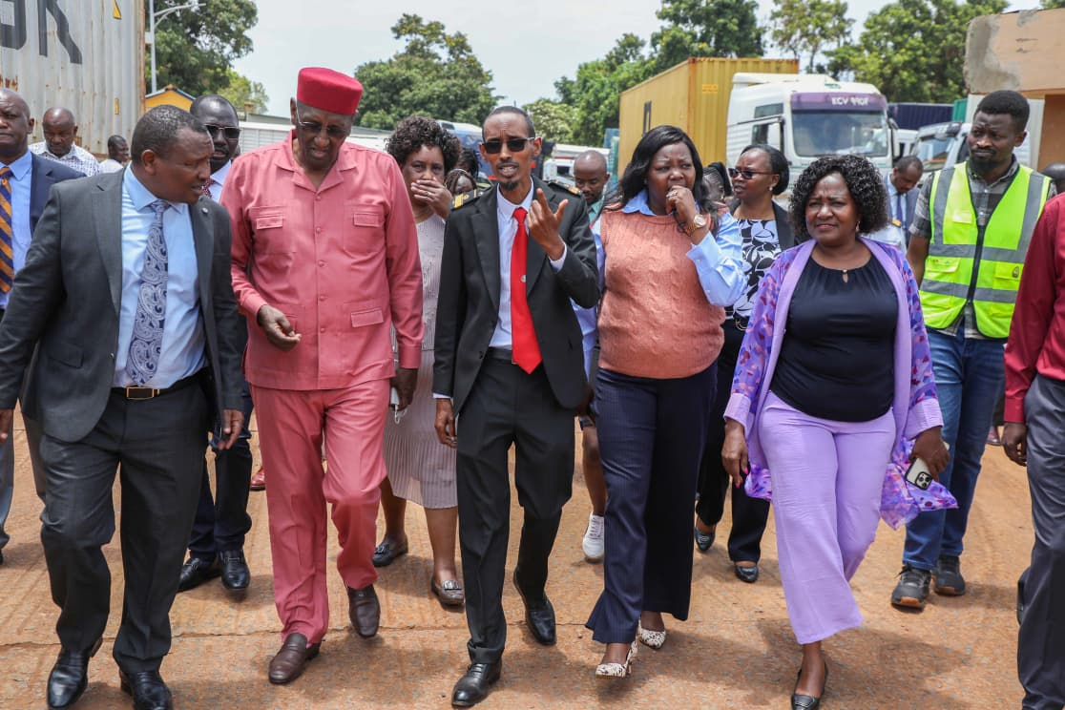
Busia One Border Post Inspection visit

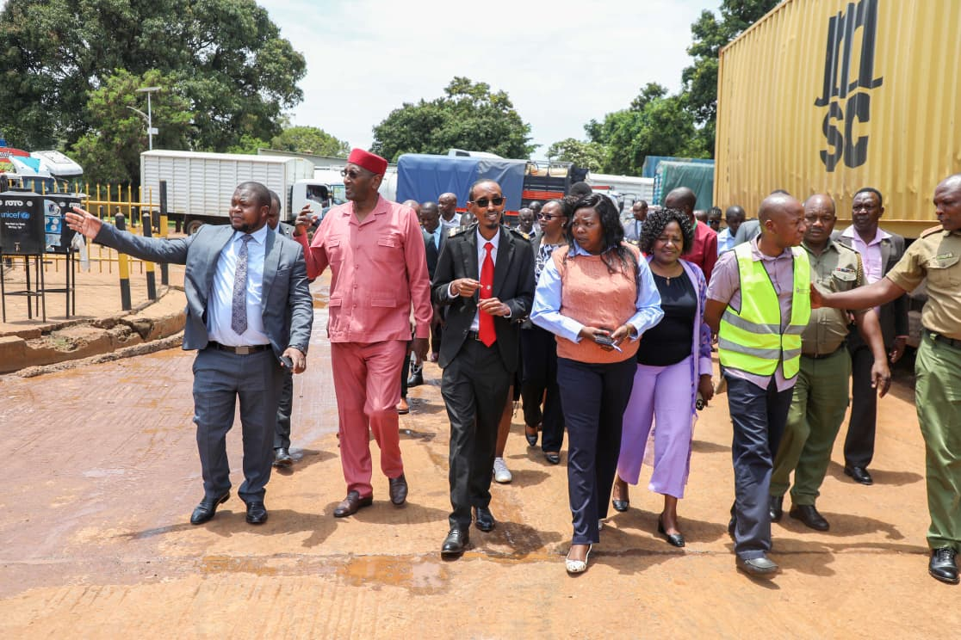
Inspection of the Warehouse and Parking Yard at the Busia One Stop Border Post.

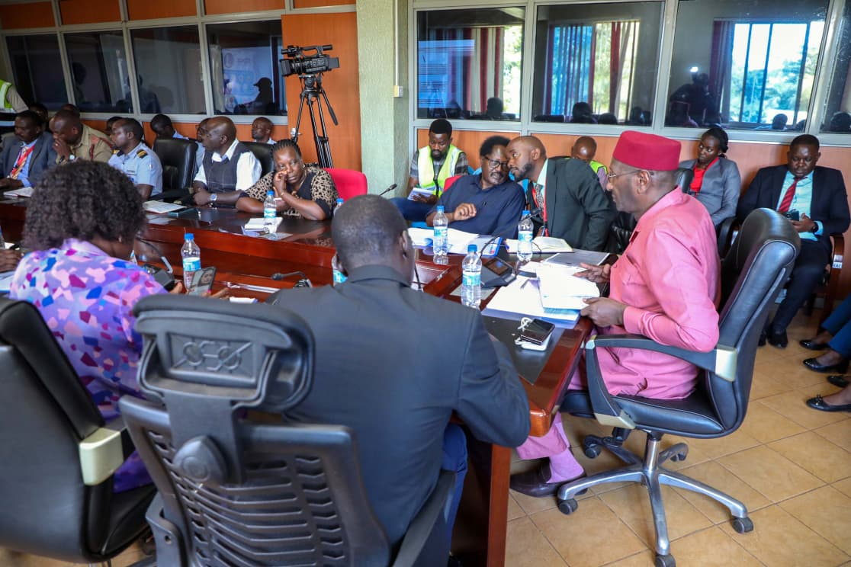
Meeting with the Busia Boarder Management Committee

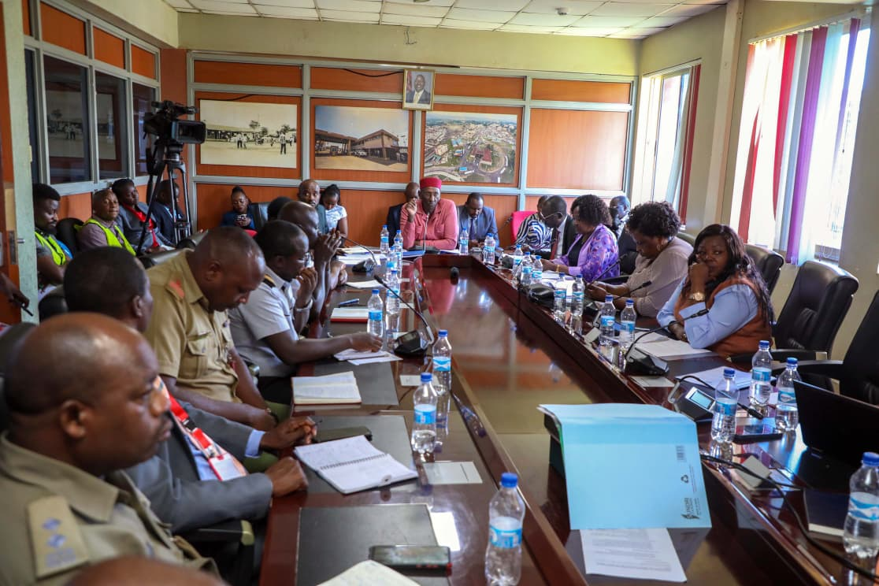
Meeting with the Busia Boarder Management Committee
  - STANDING COMMITTEE ON AGRICULTURE, LIVESTOCK AND FISHERIES

The Standing Committee on Agriculture, Livestock and Fisheries is mandated to consider all matters relating to agricultural production, irrigation, livestock, fisheries development, agricultural policy, marketing, research, and related activities.

As part of its oversight mandate, the Committee conducted inspection visits to key agricultural and fisheries installations in Busia County on Tuesday, 7th October 2025, during the Senate Mashinani sittings.

The Committee visited the following sites:
- Mulukoba Beach Management Unit (BMU), Port Victoria
- National Cereals and Produce Board (NCPB) Depot, Malaba
- Olepito Sugar Factory

This chapter highlights the Committee’s findings and recommendations arising from the visits.
- MULUKOBA BEACH MANAGEMENT UNIT (BMU) (TUESDAY, 7TH OCTOBER, 2025)
Beach Management Units (BMUs) are community-based organizations established to co-manage fishery resources in partnership with the government. They play a critical role in maintaining landing sites, enforcing fishing regulations, collecting fisheries data, and promoting sustainable fishing practices.
The Committee noted that BMUs play a central role in co-managing fisheries resources and supporting the local fishing economy. However, fishermen continue to face persistent harassment by Ugandan authorities, dwindling fish stocks due to overfishing and illegal gear, and challenges resulting from unharmonised regional fisheries policies. The team also observed significant infrastructure damage caused by rising lake water levels, as well as unresolved land ownership disputes that discourage investment in fisheries sites. The Committee recommends strengthened intergovernmental collaboration, the enforcement of quality standards on imports to protect local markets, increased investment in fisheries infrastructure and research, transparent auditing of BMU funds, and expedited reforms to fisheries and agricultural legislation.

- NATIONAL CEREALS AND PRODUCE BOARD (NCPB) MALABA DEPOT- (THURSDAY, 9TH OCTOBER, 2025)

During its visit to the NCPB Malaba Depot, the Committee examined the facility’s capacity to support national food security initiatives, particularly the fertilizer subsidy programme. The Committee established that centralized distribution has made fertilizer costly and inaccessible for many farmers, while weak coordination between national and county governments has limited effective implementation. Incomplete farmer registration data, under-resourced soil testing facilities, weak extension services, and inadequate storage and quality control systems were also noted. The Committee recommends amending the fertilizer subsidy framework to enable last-mile distribution and to include inputs for cash crops, establishing a unified national farmer register, and putting in place a fast-tracked system for the disposal of counterfeit fertilizers. It further recommends decentralizing fertilizer distribution in Busia, diversifying fertilizer types, aligning supply timelines with planting seasons, upgrading soil testing capacity, and strengthening border surveillance to prevent the circulation of fake products.

- OLEPITO SUGAR FACTORY (THURSDAY, 9TH OCTOBER, 2025

Olepito Sugar Factory, a private mill in Busia, is a vital investment supporting 350 direct staff and over 30,000 farmers. It has an installed crushing capacity of 1,500 TCD but operates at 60% capacity due to operational challenges. The factory contributes CESS levies to the county but faces threats that undermine productivity and profitability.

The Committee found that the factory operates at only 60 percent capacity due to systemic challenges. These include widespread cane poaching and premature harvesting by competing millers, dependence on rain-fed cane, weak regulatory enforcement by the Kenya Sugar Board, and the flooding of the market with cheap or illicit sugar. Poor feeder road conditions, despite the factory’s CESS contributions, continue to increase transport costs and diminish cane quality, while high production expenses undermine competitiveness. The Committee recommends stronger regulatory enforcement, enhanced border surveillance, and the digitisation of weighing and payment systems. It also calls on the County Government to link CESS collections to feeder road rehabilitation, to enact a County Sugar Cane Act to regulate harvesting and transport, and to expand irrigation. The Committee further encourages millers to strengthen farmer relations through transparent and timely payments and to pursue diversification into ethanol, electricity generation from bagasse, and industrial sugar.

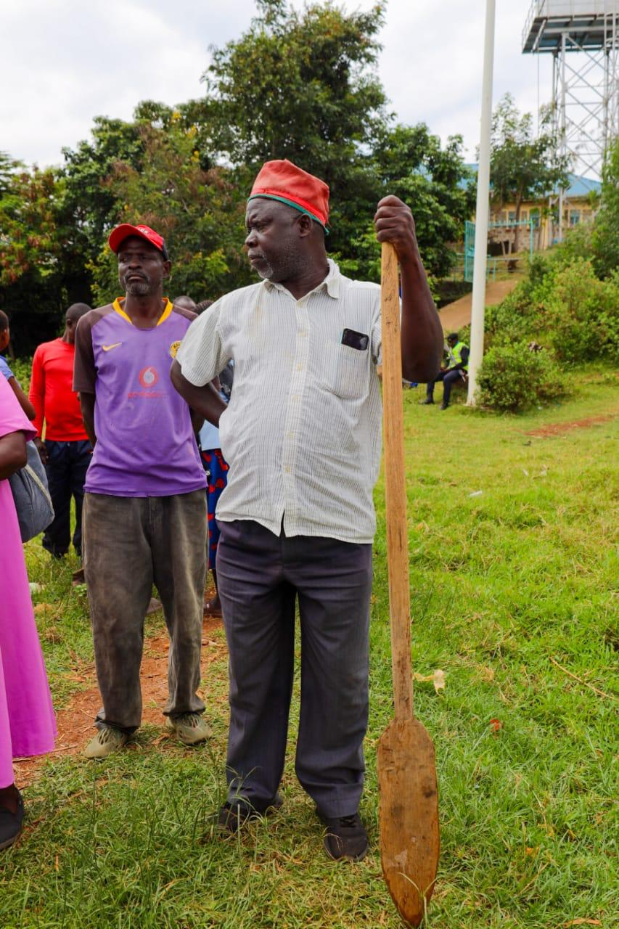
A farmer follows committee proceedings at Mulukoba BMU

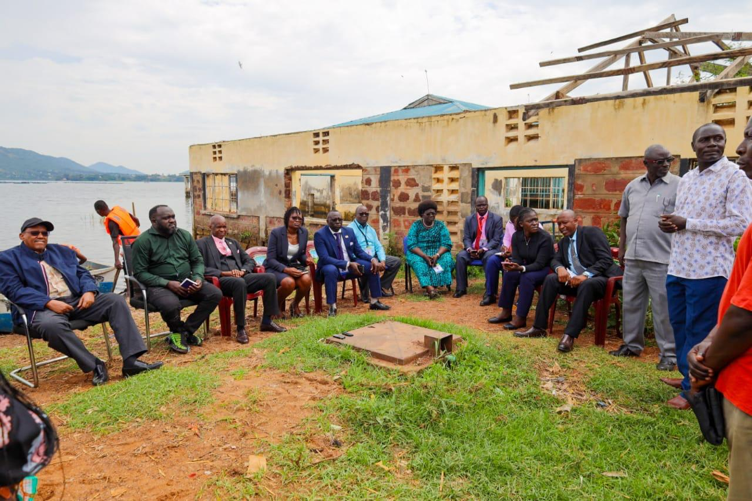
Stakeholder engagements on Fisheries at Mulukoba BMU

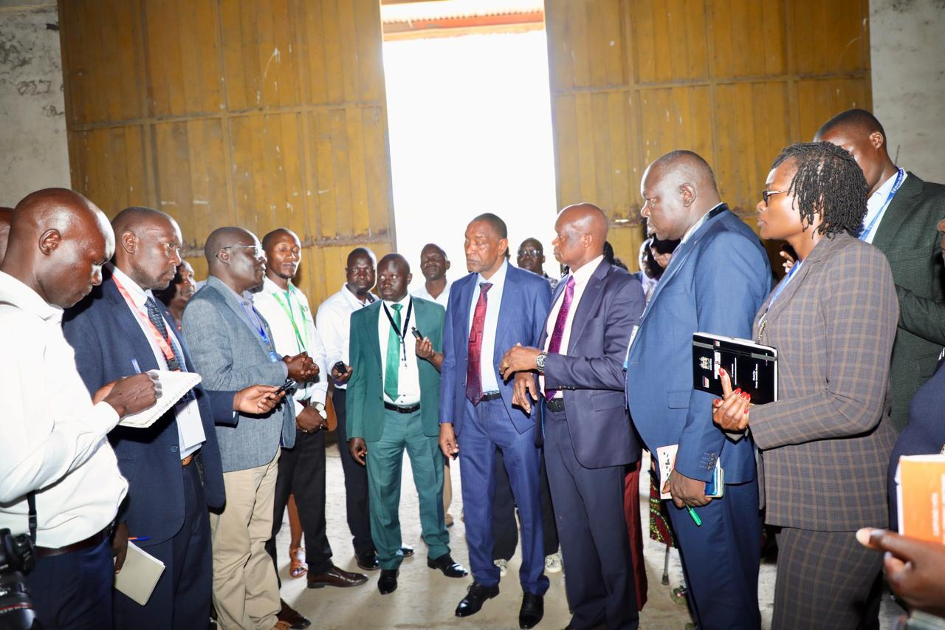
The Committee flanked with Members of the County Assembly Agriculture Committee at the NCPB Depot in Malaba

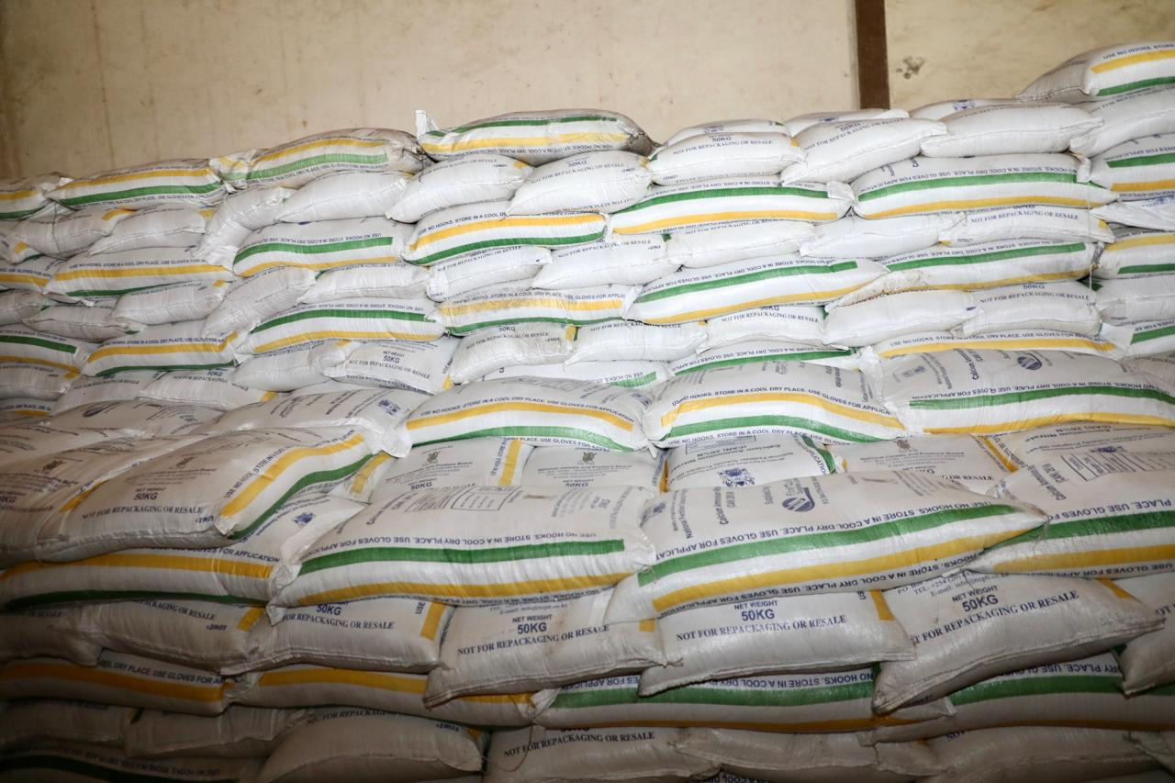
Stock at the NCPB, Malaba

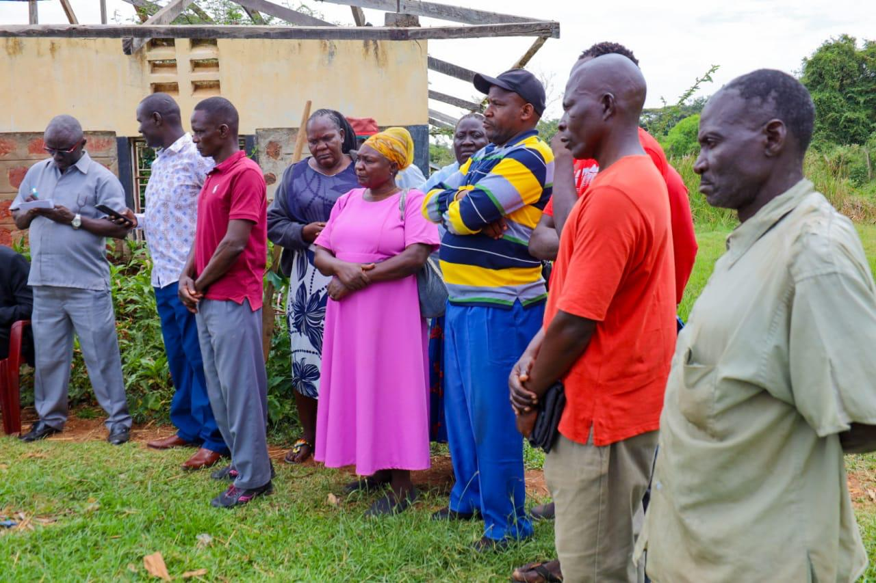
Fishing Community follows the committee proceedings at the BMU

  - STANDING COMMITTEE ON FINANCE AND BUDGET
The Standing Committee on Finance and Budget met with the Governor of Busia County and deliberated on the status of pending bills and the performance of Own Source Revenue (OSR).
During deliberations, the Committee made the following observations regarding pending bills in Busia County:

- As at 30th June 2025, the County Executive had accumulated pending bills amounting to Ksh. 2.65 billion, mainly in the Departments of Health, Finance, Governorship, Lands, PSM, and Education.
- There was a discrepancy of Ksh. 12.83 million between figures submitted to the Committee and those submitted to the Office of the Controller of Budget (CoB).
- Some pending bills were omitted from the report sent to the CoB and later included in the version submitted to the Committee, though no formal communication had been made to CoB regarding the revision.
- Pending bills rose sharply from Ksh. 1.77 billion in FY 2020/21 to Ksh. 2.65 billion in FY 2024/25, with the largest increase between FY 2023/24 and 2024/25.
- The County’s plan to clear the Ksh. 2.6 billion in two fiscal years (FY 2025/26 and 2026/27) — Ksh. 1.3 billion per year — appeared unrealistic.
- Unpaid statutory deductions amounted to Ksh. 858.12 million, with arrears prioritized in remittance.
- The County Assembly reported pending bills of Ksh. 620.48 million, despite the Senate allocating dedicated budgets annually as costed by the CRA.

Regarding Own Source Revenue performance, the Committee noted that—

- The County has consistently missed revenue targets in the last three fiscal years (FY 2022/23–2024/25).
- Health facilities contributed 25–40% of OSR through the Facility Improvement Fund (FIF).
- Actual collections were 47% of potential revenue in FY 2024/25, 34.2% in FY 2023/24, and 18.7% in FY 2022/23, showing persistent underperformance.
- The County is developing land rating regulations to expand the tax base to include freehold properties, but was advised to gazette the regulations as required under the Statutory Instruments Act, Cap. 2A, for legal effect.
Committee Resolutions
- The County Executive to reconcile and resubmit accurate pending bills data to the Committee and the CoB within 21 days.
- The Committee to hold a follow-up meeting upon receipt of the reconciled report.

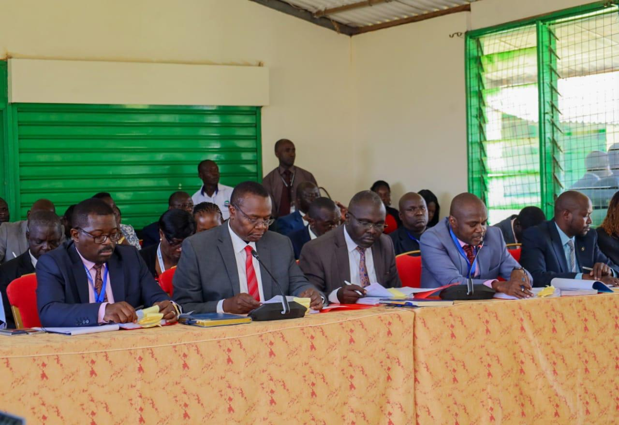
County Executive of Busia submitting to the Committee on Finance and Budget status of pending bills and performance of Own Source Revenue
  - STANDING COMMITTEE ON HEALTH

The Committed inspected the Busia County Referral Hospital on the status of healthcare provision
Committee observations and resolutions
Managed Equipment Scheme (MES) and Dialysis Services
- The Medical Superintendent confirmed that dialysis services had stopped after a power surge damaged all four dialysis machines. Patients seek the services from Bungoma County Referral Hospital.
- The hospital had sought direct procurement approval to replace the machines, but delivery delays persisted.
- The Committee questioned why no formal follow-up had been made with the Ministry of Health or Kenya Power for compensation.
The Committee directed the Office of the County Governor and the Busia County Referral Hospital management ensures that all dialysis services are restored within thirty (30) days and submit a compliance report to the Committee upon completion.
Essential Services and Equipment
Service/ Facility | Status | Committee Observation
ICU | Not operational – lacks anaesthesiologist | Severe gap in critical care capacity; unacceptable for a referral hospital.
Oxygen Plant | Installed but non-functional due to valve issues | Immediate maintenance required.
CT scan | Operational | Only one fully functional MES equipment.
X-Ray | Partially functional | Requires replacement.
Ambulances | Only one fully operational functional located at Alupe; another ambulance was procured, however, it was rejected during delivery since it did not meet the requirements | Procurement flaws and delayed replacement.
The Committee directed that;
- The ICU, Oxygen Plant, and Dialysis Units be fully operationalized by the end of the current quarter of the financial year, and in any case not later than November.
- The Busia County Referral Hospital shall submit evidence of corrective procurement measures regarding the rejected ambulance within thirty (30) days, noting that it is unacceptable for a referral hospital of such scale to operate without a functional ambulance.
Drug Supply and KEMSA Relationship
- It was observed that the hospital owed Kenya Medical Supplies Authority (KEMSA) Kshs. 29 million, down from Kshs.180 million.
- Order fill rate from KEMSA ranged between 30–40%, thus the hospital has to procure from Mission for Essential Drugs and Supplies (MEDS), a mission-based supplier.
- Senators observed that patients continue to purchase medication from private pharmacies situated directly opposite the hospital, suggesting possible sabotage for profit by hospital staff and collusion between doctors, pharmacists, and external pharmacies. The proliferation of such pharmacies around the facility further points to potential insider diversion of drugs or systemic procurement failures within the hospital.
The Committee directed that;
- The County Executive to audit the licensing and operations of all private pharmacies located adjacent to the hospital to establish potential collusion or unethical practices involving hospital staff.
- The Busia County Referral Hospital to implement a digital stock management and tracking system to enhance transparency, prevent drug diversion, and ensure accountability in pharmaceutical inventory management.
Social Health Authority (SHA) and NHIF Reimbursements
- The hospital reported having received Ksh.62 million from the Social Health Authority (SHA), against a total of Ksh.77 million in claims submitted, out of which Ksh.14.3 million were rejected. It was further reported that no disbursements were received in August 2025, and that reimbursements have been irregular and delayed, severely crippling hospital operations.
- As a result, the facility has experienced drug shortages, accumulation of unpaid bills and difficulties in meeting recurrent expenditures.
- The Committee noted systemic inefficiencies within the SHA, including delayed claim processing and approval bottlenecks, compounded by incomplete or inconsistent documentation from the hospital side.

Consequently, the Standing Committee on Health resolved that it shall engage the leadership of the SHA to:
- Expedite the settlement of pending claims from public hospitals; and
- Develop and deploy an electronic claims submission and tracking system to enhance efficiency, transparency, and accountability in reimbursement processing.

The Committee engaged the County Health Department and the Medical Superintendent and deliberated on the hospital’s operational framework and proceeded to inspect-
- The Pharmacy;
- Morgue and
- Maternity Ward

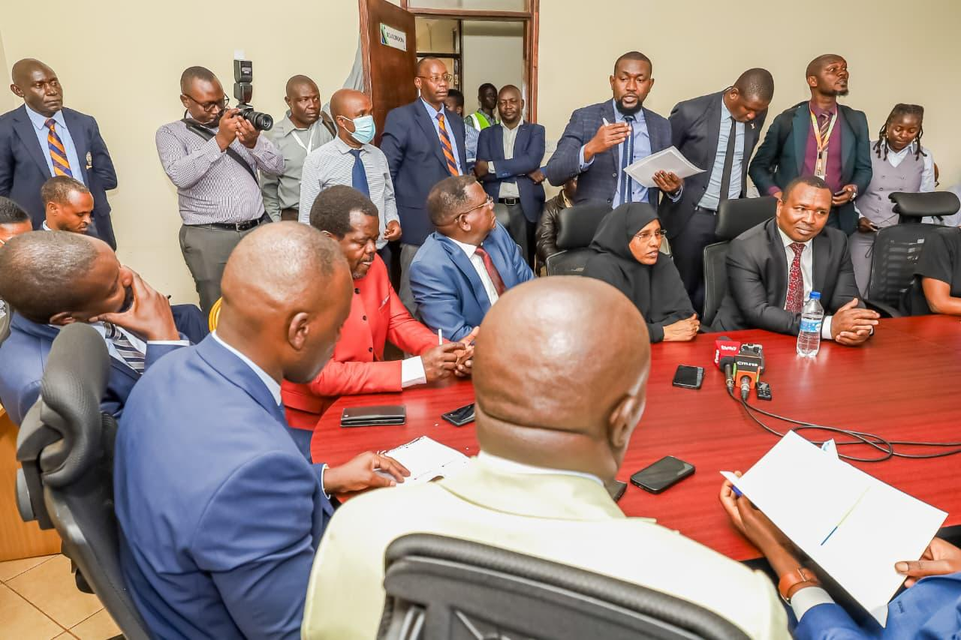
The Committee engaging officers from the Department of Health at Busia County

  - STANDING COMMITTEE ON NATIONAL SECURITY, DEFENCE AND FOREIGN RELATIONS

The Standing Committee on National Security, Defence and Foreign Relations was scheduled to meet with the Cabinet Secretary for Interior and National Administration in Busia to deliberate on the current police recruitment modalities and processes within Counties. However, the meeting was postponed due to the Cabinet Secretary's participation in the 24th COMESA Summit that coincided with the scheduled meeting.

  - SELECT COMMITTEE ON COUNTY PUBLIC ACCOUNTS

- Meeting with the Busia County Executive Management to address the unresolved issues raised in the Auditor-General’s Report on the Financial Statements of the County Executive of Busia and the Report of the Auditor General on Receiver of Revenue Statements for Financial Year 2023/2024 -

The Committee met with the County Executive Management to consider unresolved issues arising from the Auditor-General’s Report on the Financial Statements of the County Executive of Busia and the Report on the Receiver of Revenue Statements for the Financial Year 2023/2024. The County Assembly Public Accounts Committee informed the Committee that it had not yet adopted the reports due to a backlog of pending audit matters. The Committee urged the County Assembly to fast-track consideration and adoption of the reports in line with the High Court decision in Republic v Nairobi City County Assembly & another; Musumba & 4 others (Exparte) (Application E082 of 2023), delivered on 1st October 2024, which requires timely legislative action on audit reports.

The Committee noted a pattern in the County’s procurement practices where numerous projects and consultancy services had been costed at approximately Kshs.4.9 million each, suggesting potential contract splitting to facilitate direct procurement. The Committee requested the EACC to investigate whether these practices were deliberately used to circumvent procurement laws.

Regarding the revenue collection system, JamboPay/Webtribe, the Committee observed persistent challenges similar to those reported in other counties. Members agreed that if systemic weaknesses are proven, the Committee may consider invoking provisions of the Public Audit Act to recommend debarment of the service provider. Although the provider charges a commission rate of six percent, the Committee noted the absence of a benchmark for commission rates across counties and resolved to gather comparative data to determine whether the fees charged are justified and why they differ among counties offering similar services.

On the Auditor-General’s Report on Receiver of Revenue Statements, the Committee highlighted the significant disparity between the CRA’s estimated revenue potential of Kshs.2.2 billion and the County’s actual collection of Kshs.357,765,802, despite Busia’s strategic border location. The Committee noted unexplained declines in several revenue streams between FY 2022/2023 and FY 2023/2024, including hospital fees, physical planning fees, and trailer parking fees, though bus park fees had increased. The County was unable to provide satisfactory explanations for these variances. The Committee further observed that the CECM for Finance, Hon. Topister Naiti Wanyama, violated Section 157 of the Public Finance Management Act by designating herself as the County Receiver of Revenue, contrary to statutory requirements.

The Committee also revisited prior-year matters raised by Sen. Okiya Omtatah, including procurement issues relating to JamboPay, the Governor’s Lodge renovation, a refrigerated truck, the town beautification programme, and alleged fraudulent procurement of medical supplies. The Committee noted that the Governor’s Lodge project had not been included in the 2023/2024 audit report because EACC had seized the relevant documents. The Committee resolved that the matter be addressed in the 2024/2025 audit cycle.

The EACC briefed the Committee on ongoing investigations in Busia, now at the evidence-analysis stage, covering fraudulent procurement of medical supplies, consultancy contracts linked to the industrial-park project, pending bills under the Department of Trade and Investment, and irregular disbursements amounting to Kshs.22 million channelled through personal assistants.

Pictures:

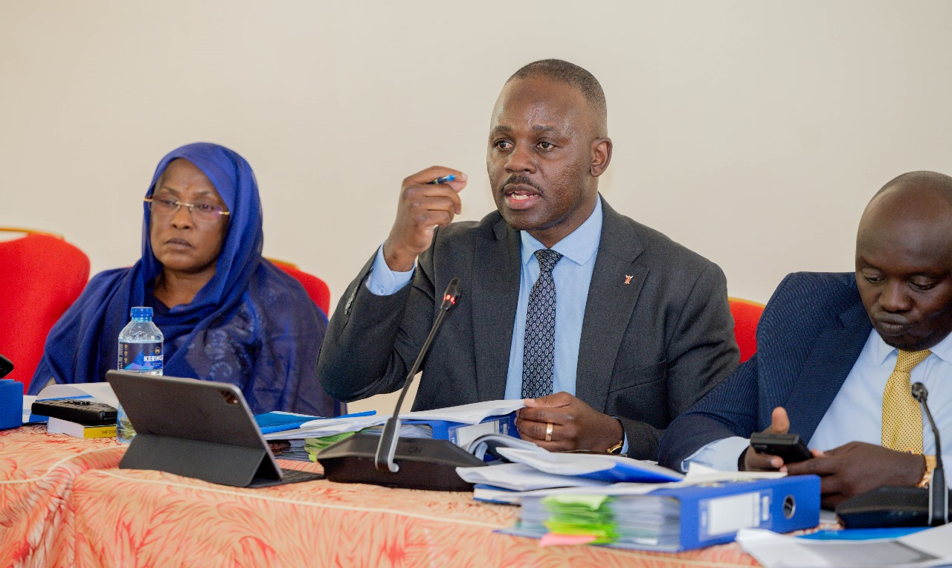

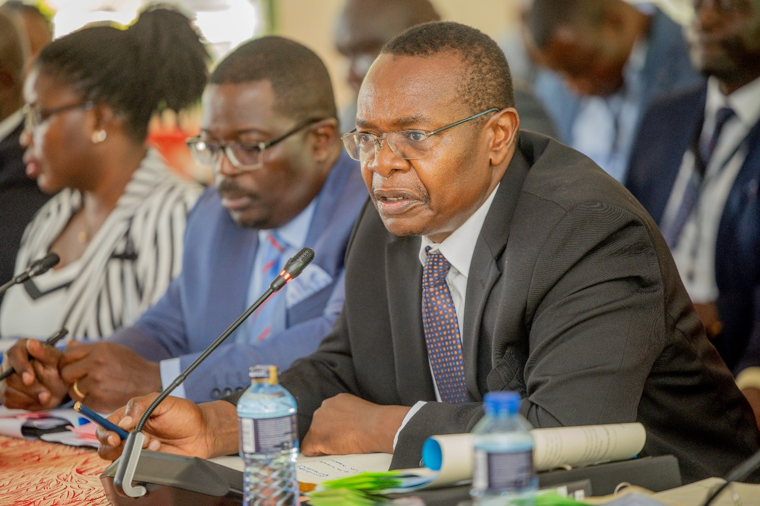
Meeting with the Governor Busia County to interrogate Auditor General’s Report

- Meeting with the Busia County Assembly Management to address the unresolved issues raised in the Auditor-General’s Report on the Financial Statements of the County Assembly of Busia

The Committee met with the Busia County Assembly Management to address unresolved issues arising from the Auditor-General’s Report on the financial statements of the County Assembly of Busia. It first questioned the legality of appointing an Acting Clerk despite the presence of a substantive Deputy Clerk, noting that Section 21(4) of the County Assembly Services Act expressly mandates the Deputy Clerk to perform the Clerk’s duties in the event of a vacancy or absence. The Committee found the appointment of the Director of Finance unlawful and indicative of poor corporate governance, and it directed the County Assembly Service Board to comply strictly with the Act.

The Committee noted that the Assembly had 128 staff, including 11 drivers for only two vehicles, while lacking essential technical staff such as certified accountants, auditors, and legal officers. Overstaffing in non-core areas, coupled with shortages in critical professional roles, had weakened the Assembly’s institutional capacity. The Committee recommended an organisational review, declaration of redundant positions as required by the Employment Act, and prioritised recruitment for key technical cadres.

On compensation of employees, the Committee observed an unexplained increase of Kshs. 100 million between FY 2022/2023 and 2023/2024. The explanations provided were inconsistent, and the Auditor-General confirmed irregular accounting treatment. The Committee recommended a forensic review of the payroll by the EACC and the Auditor-General.

During its inspection of the Busia County Referral Hospital, the Committee noted that the county owed KEMSA Kshs. 29 million, with an order fill rate of only 30 to 40 percent, forcing the hospital to procure drugs from MEDS. Concerns were raised about reports of patients being directed to private pharmacies opposite the hospital, suggesting diversion of drugs and collusion. The Committee directed the County Executive to audit the licensing and operations of these pharmacies and instructed the hospital to install a digital stock-management system.

On SHA reimbursements, the hospital reported receiving Kshs. 62 million against claims of Kshs. 77 million, with irregular and delayed disbursements contributing to drug shortages and unpaid bills. The Committee resolved to engage SHA to expedite pending payments and implement an electronic claims-tracking system.

The Committee reviewed pending bills amounting to Kshs. 248.4 million. After verification, only Kshs. 196 million were deemed eligible, with Kshs. 104 million still outstanding. It noted that some debts were more than three years old and highlighted financial management weaknesses. The Assembly was directed to submit a time-bound payment plan to the Controller of Budget, while the Auditor-General was instructed to authenticate the bills.

The Committee also found unremitted statutory and third-party deductions totalling Kshs. 79 million, with Kshs. 16 million in accrued interest and Kshs. 10 million in unpaid taxes, amounting to unlawful diversion of employee deductions. The Committee directed immediate prioritisation of all statutory remittances and recommended investigations by the Auditor-General and EACC for potential personal liability.

On procurement, the Committee reviewed Kshs. 4.99 million spent through direct procurement for works at the Speaker’s residence without justification and referred the matter to the EACC. It also examined the Kshs. 4.9 million consultancy for the proposed upgrade of the County Referral Hospital and found that the report did not provide value for money, with most content copied from public sources. The matter remains under EACC investigation.

The Committee further established that Kshs. 59 million had been paid for the JamboPay/Webtribe hospital automation system, which remained non-functional, with administrative rights retained by the vendor and a termination clause carrying a Kshs. 70 million penalty. It found the procurement irregular and directed the Auditor-General to conduct a forensic system audit.

On the Managed Equipment Scheme, it noted that dialysis services had stopped following a power surge that destroyed all machines, with delayed replacements and no follow-up for compensation. It directed the County Governor’s Office and Hospital Management to restore services within 30 days.

The Committee concluded by emphasising the need for stronger governance, transparent procurement, compliance with public finance laws, and strengthened institutional professionalism across the County Assembly and the County Referral Hospital.

CHAPTER 4

CHAMBER, OFFICES AND COMMITTEE ROOMS

Chamber

In preparation for the sittings of the Senate, officers drawn from the Directorate of Engineering and Maintenance Services determined the scope of the renovation works required at the County Assembly of Busia. Thereafter, the required Bills of Quantities were prepared in order to facilitate procurement of the necessary works. M/S Turks Consultants Limited was appointed to execute the renovation works after conclusion of the tender process.

The table below provides details of the works carried out by the Senate for purposes of the Senate Mashinani sittings in Busia County –

 | Description of Item | Total Cost (Ksh)
 | Proposed Works at the County Assembly of Busia | 4,427,970.00
 | Proposed Installation of Carpets in the Offices of the Speaker and Clerk of the County Assembly of Busia | 1,459,000.00

It is also worth to note that a Speaker’s Chair specifically made for the historic sitting was presented to the Speaker of the Busia County Assembly as a token of memento for remembrance. The cost of the chair was Kshs. 140,000 from M/s Kenya Prison Services.

Leadership Offices

The Speaker of the Senate, Deputy Speaker, Leaders of Majority and Minority were all accommodated in the offices of the host leadership offices at the County Assembly premises, while the rest of the senators were at the Members’ Lounge, where a tent had been pitched at the parking yard. The offices satisfactorily served the purpose.

The Senate Serjeant-at-Arms was tasked to ensure that security was maintained in the dining tents, availability of refreshments for Senators and high standards of hygiene maintained in the tents and Speaker’s holding room.

Committee Rooms and Office Space
The Office Tower, Finance Block and Annex building offered suitable office space for all Directorates/Departments and some committee rooms. The ATC halls at the Busia Agricultural Training Centre were used to hold Committee meetings.

The ATC Halls were hired for five (5) days at a cost of Kshs. 99,000, whereas an additional Kshs. 50,000 was paid for the Public Address System.

The tender for the supply of furniture for the offices at the Annex building and Senators’ Lounge was awarded to M/S Itoya Hotel Limited.

ICT Equipment

The procurement of ICT equipment was successfully done in collaboration with the procurement department. Additional portable MiFis were given to directors and committee clerks to facilitate their work.

Additionally, the ICT officers identified specific points for network extension as indicated below:
- The parking area/Members’ Lounge
- Media Holding Center
- The Office Tower
- The Finance Block
- The Main Chamber

 | Description of Item | Total Cost (Ksh)
 | Supply and Delivery of 200 mbps Bandwidths and Wireless mifi 5G Connectivity Services during Senate Mashinani | 384,772.00
 | Supply and Delivery of 200 mbps Bandwidths and Wireless mifi 5G Connectivity Services during Senate Mashinani | 384,772.00

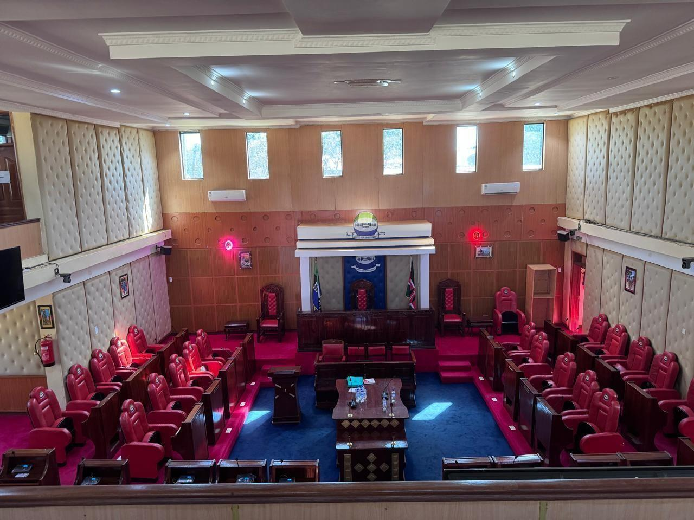
Interior of the Busia County Assembly Chamber
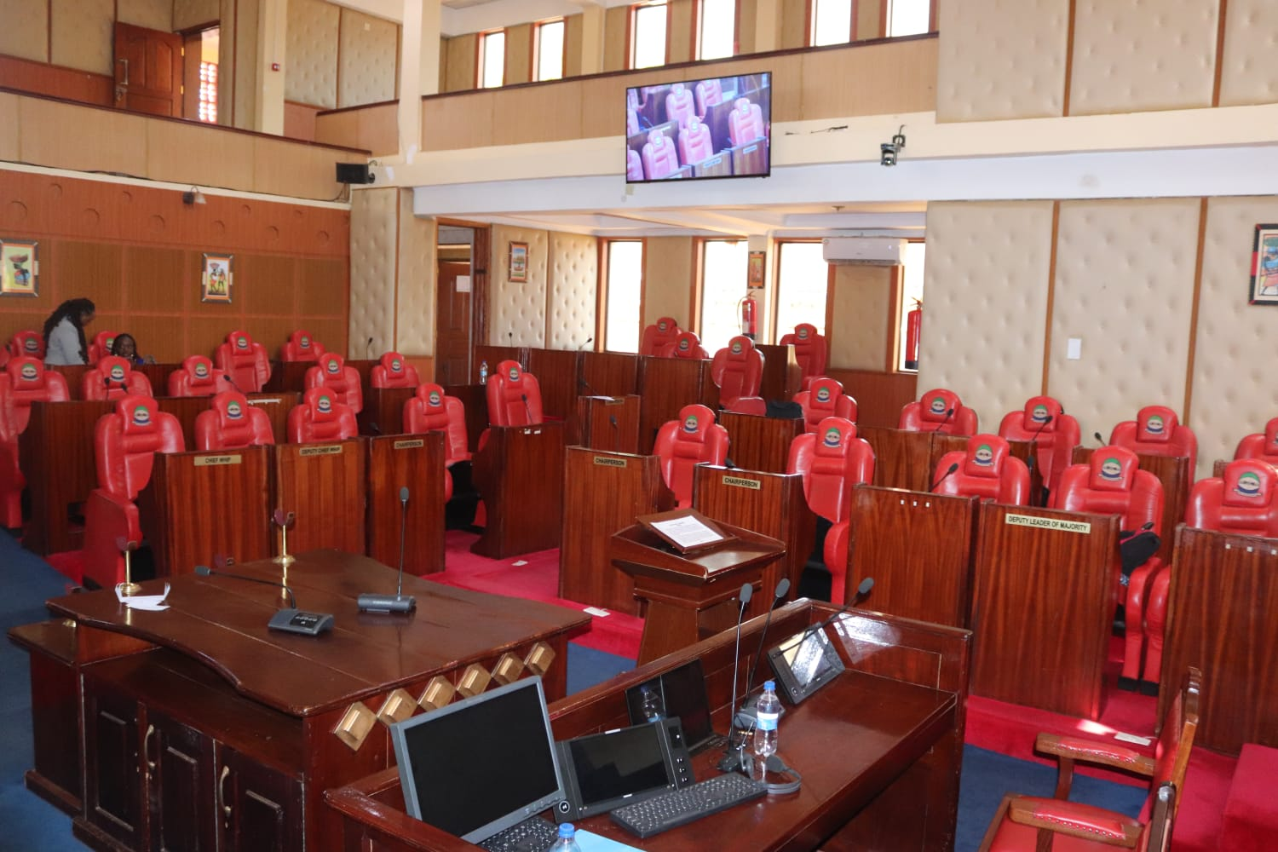
Interior of the Busia County Assembly Chamber

CHAPTER 5

5.1 MEDIA AND BROADCASTING OF SENATE PROCEEDINGS

This chapter provides an overview of the media relations activities undertaken before, during, and after the Senate Mashinani sittings held in Busia County from 6th to 10th October 2025. It outlines the objectives, execution, outcomes, challenges encountered, and key recommendations for future improvement.

OBJECTIVE

The objective of deploying a Media Relations team to Busia County was to ensure comprehensive media coverage of the Senate Mashinani sittings. The team’s primary mandate was to coordinate both internal and external publicity through structured dissemination of information across mainstream media, social media platforms, and official parliamentary communication channels. The goal was to enhance public awareness of the Senate’s outreach initiative, highlight committee engagements with county leadership, and showcase the Senate’s continued commitment to devolution and citizen participation.

DURING SENATE MASHINANI

During the sittings, the Media Relations team collaborated closely with parliamentary journalists who possess in-depth knowledge of parliamentary terminology and legislative procedures, ensuring professional, accurate, and timely coverage of the proceedings. Coverage was extended to the following Senate Committees and forums: Health, Education, Energy, Agriculture, and the Kenya Women Senators Association (KEWOSA).

The team successfully organized press conferences and interviews with Senators, which significantly enhanced reportage, strengthened the Senate’s image, and increased visibility of the Mashinani sittings in Busia County. Coverage was achieved across both internal and external platforms.

CHALLENGES

However, challenges were experienced including last-minute meeting schedules, inadequate airtime, and lack of a soundproof recording booth for radio partners.

OUTCOME

Upon conclusion of the sittings, the Media Relations team compiled and disseminated comprehensive coverage reports summarizing key committee sessions, Senatorial engagements, and deliberations. Content was uploaded on the Senate’s digital platforms and shared with mainstream media outlets for broader public reach. The concerted efforts of the team resulted in enhanced visibility, transparency, and public engagement, reinforcing the Senate’s image as a people-centered legislative institution.

BUDGET

To support the communication and publicity efforts before and during the Busia sittings, a dedicated budget was utilized for the production of an internal advert and other related media activities. The advert, produced by the Parliamentary Broadcasting Unit (PBU) in collaboration with an external professional contractor, was a 30–60 second production in English, Swahili, and the local dialect. It was aired on Senate TV, Facebook, X, YouTube, the Parliament website, and local FM radio stations to promote public participation.

Item | Rate (KES) | Units | Days | Total (KES)
Drone / Drone Operator | 20,000 | 1 | 2 | 40,000
Video Editor + Edit Suite | 32,500 | 1 | 2 | 65,000
Imaging & Colour Grading | 45,000 | 1 | 1 | 45,000
Graphic Designer & Sound Effect | 50,000 | 1 | 1 | 50,000
Total Production Cost |  |  |  | 200,000
Total Budget was Charged to: Office of the Clerk Vote Head 2210703 (Advertising, Awareness and Publicity Campaigns)

RECOMMENDATIONS
- Early Planning and Coordination: Develop and circulate a comprehensive media plan at least two weeks prior to future Senate Mashinani events.
- Adequate Airtime and Data Allocation: Ensure timely provision of airtime and data bundles to facilitate real-time content sharing and online engagement.
- Provision of Media Facilities: Allocate a designated media recording booth or quiet space to support radio and broadcast journalists.
- Enhanced Collaboration: Strengthen partnerships with county communication officers and external journalists to improve coverage reach and consistency.
- Post-Event Evaluation: Conduct a formal debrief session to assess the event’s media performance, capture lessons learned, and apply improvements in future engagements.
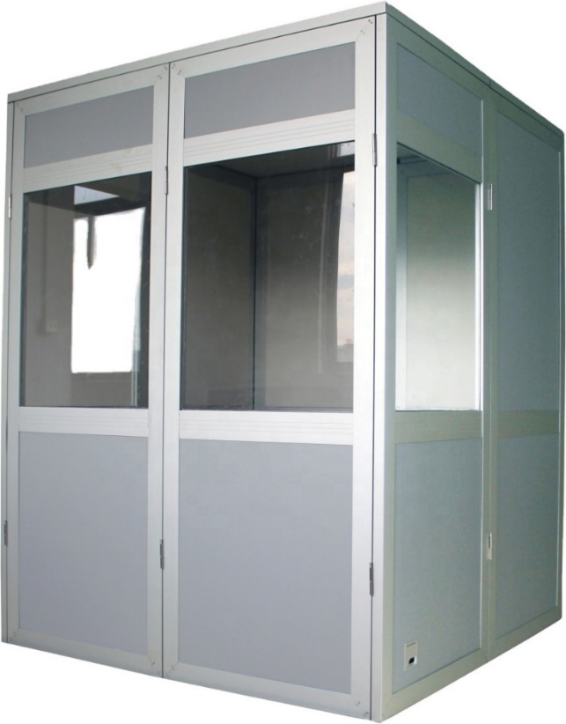
Sound Booth

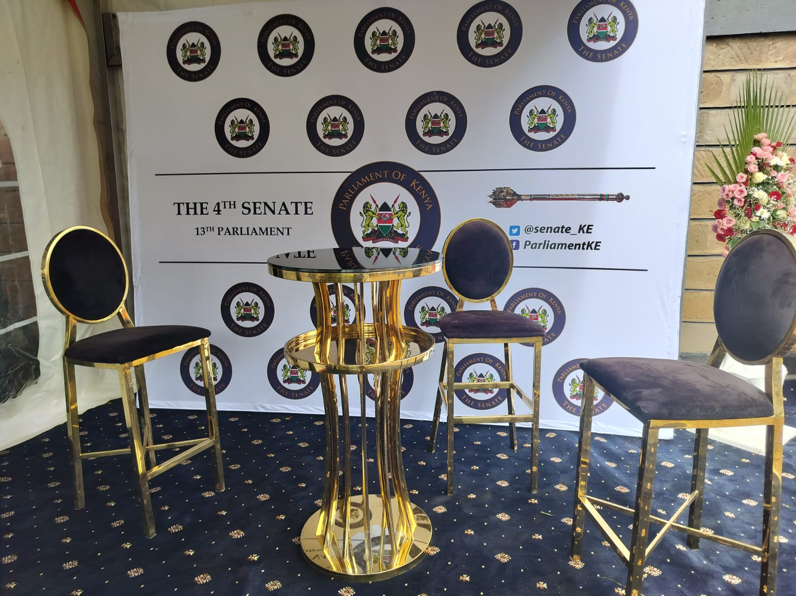
Interview Stand
5.2 SENATE EXHIBITION FOR CIVIC AWARENESS

The Senate Liaison Office (SLO) successfully participated in the Senate Mashinani outreach program in Busia County. Held from 6th to 10th October 2025, the initiative engaged a total of 1,311 participants across 32 educational facilities, demonstrating strong community involvement.

In collaboration with the Public Communication Department, the SLO established an interactive exhibition booth to engage community members and showcase parliamentary functions. The engagement activities facilitated direct interaction between citizens and parliamentary representatives, enhancing public understanding of Parliament's role and promoting transparency and civic awareness. The program's strategic focus on youth and children resulted in 1,044 student participants, positioning it to influence long-term civic participation. The overall gender distribution was relatively balanced, with 47% female and 53% male participants.

In alignment with Parliament's public outreach framework, the Senate Liaison Office was allocated space within the Busia County Assembly. The SLO team's objectives included:
- Clarifying the function and structure of the Senate Liaison Office.
- Articulating the Senate's role within Kenya's devolved governance structure.
- Illustrating how the SLO enables effective communication among the Senate, County Governments, and citizens.
- Offering practical exposure to parliamentary procedures and processes.

Activities Undertaken
Key activities at the exhibition stand included:
- Direct Personal Interactions: Staff members actively engaged visitors, explaining the SLO's mandate using practical examples related to devolution and the Senate's critical role in distributing national resources to counties.
- Educational Resource Distribution: Brochures and pamphlets detailing the Senate's functions and SLO-coordinated programs were disseminated. Distributed materials included:
- The County Legislative Tracker Leaflet,
- Voluntary Services Scheme Leaflet,
- SLO Handbook
- SLO Procedural Manual,
- The Senate Weekly
- Senate-branded pens.

- Informational Displays: Posters presented topics such as the Senate Vision and Mission Statements, Parliament's Mandate, Senate Leadership, the Law-Making Process, and a map of all the counties titled "Know Your County".
- Hands-On Learning Experiences: The team clarified legislative procedures, oversight responsibilities, and representational mandate, guiding the public through the operations of the Senate chamber.
- Interactive Dialogue: The stand facilitated ongoing question and answer sessions, incorporating puzzles and games to assess public knowledge and respond to inquiries about citizen engagement with the Senate on county government concerns.

Outcomes and Achievements
The program recorded a total attendance of 1,311 participants. The breakdown of attendees across categories is detailed below:
Category | Female | Male | Total | Female % | Male %
Students | 481 | 563 | 1,044 | 46% | 54%
Teachers | 51 | 37 | 88 | 58% | 42%
Community | 78 | 101 | 179 | 44% | 56%
Overall | 610 | 701 | 1,311 | 47% | 53%

The program engaged students from 31 schools and one university. The high engagement of youth (1,044 students) demonstrates the program's success in cultivating long-term democratic culture and civic participation among the young people.
Challenges and Recommendations
The program identified several areas for improvement:

 | Challenge | Recommendation
 | Timely Production and Procurement of Materials | Establish clear timelines and procurement protocols to ensure all distribution materials are produced and delivered well in advance.
 | Pre-Material Review | Review all distributed materials prior to events to identify and correct errors, ensuring accuracy and professionalism.
 | Limited Staffing at the Event | Deploy additional personnel for high-attendance events to effectively distribute the workload, minimize staff fatigue, and maintain consistent quality of engagement.
 | Limited Digital and Media Coverage | Strengthen collaboration with the Senate’s Public Communications Office and local media houses to ensure wider coverage, live streaming, and social media engagement.
 | Insufficient Time for Engagement per Institution | Extend the duration of future events or reduce the number of target institutions to allow for deeper, higher-quality engagement.
 | Limited Feedback Collection Mechanisms | Introduce participant feedback tools (e.g., forms or digital surveys) to collect qualitative and quantitative data for continuous improvement.
 | Gender and Inclusivity Gaps (Low participation from women in the general community and people living with disabilities) | Develop targeted inclusion strategies, such as working with women’s groups, youth leaders, and disability organizations to mobilize diverse participants.
 | Follow-Up and Impact Tracking | Establish a post-event monitoring framework, such as a 6-month follow-up, to track participants' engagement or interest in Senate processes.

Additional Recommendations:
- Develop a Standard Senate Mashinani Toolkit: Create a standardised resource kit for uniform quality across counties, including key messages, branded materials, presentation templates, and evaluation tools.
- Incorporate Interactive Learning Aids: Integrate short videos, animations, or interactive quizzes to enhance civic education, especially for students.
- Strengthen Collaboration with the County Assembly: Encourage joint sessions or community forums between the Senate and County Assemblies to illustrate practical aspects of devolution.
- Establish Partnerships with Educational Institutions: Formalise partnerships with schools and universities through Memoranda of Understanding (MoUs) for continuous civic education programs.

Conclusion

The Senate Mashinani program has established a robust foundation for legislative community engagement. The joint initiative between the SLO and Public Communications Department fulfilled the SLO's mandate by bridging the gap between Parliament and the public through accessible, interactive education on legislative processes and parliamentary functions. While the overall outcomes were highly successful, particularly the emphasis on youth, identified gaps include persistent gender disparities among students and community attendees, and limited adult community participation, which present opportunities for strategic enhancement.

With the recommended refinements, the program can evolve from a successful outreach initiative into a transformative model for strengthening the relationship between elected representatives and their constituents.

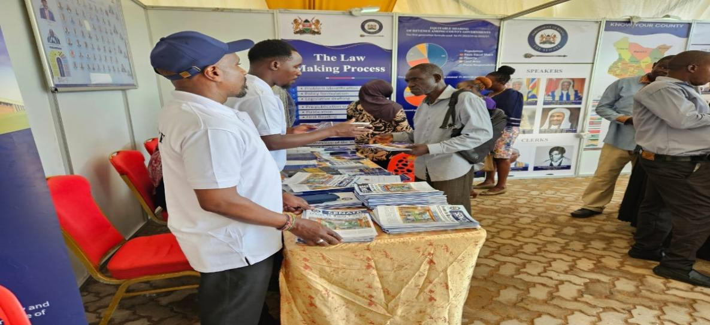

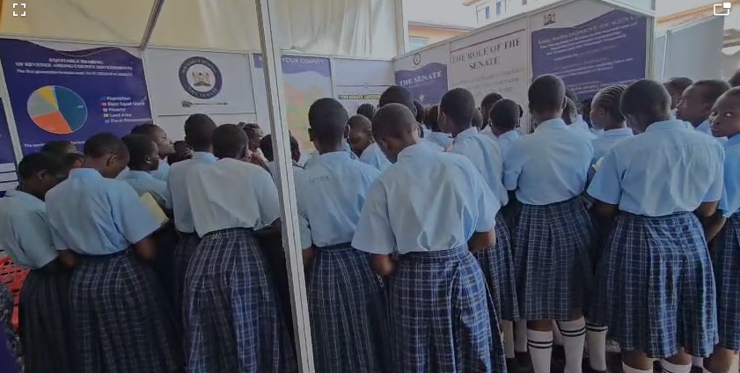

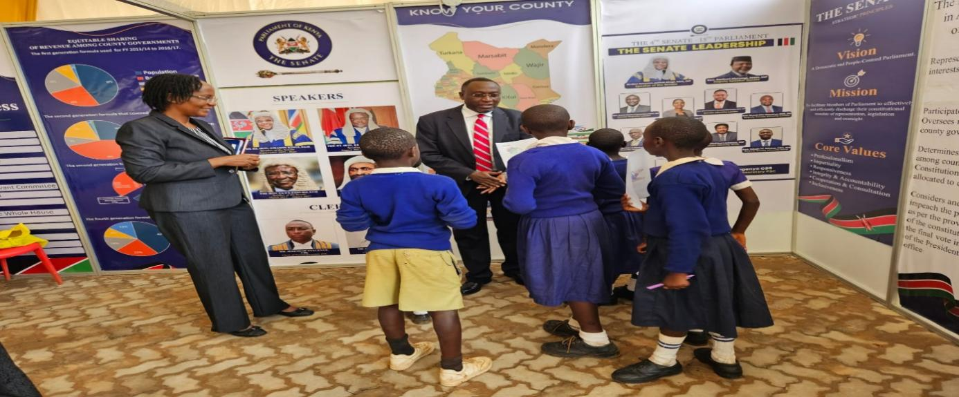

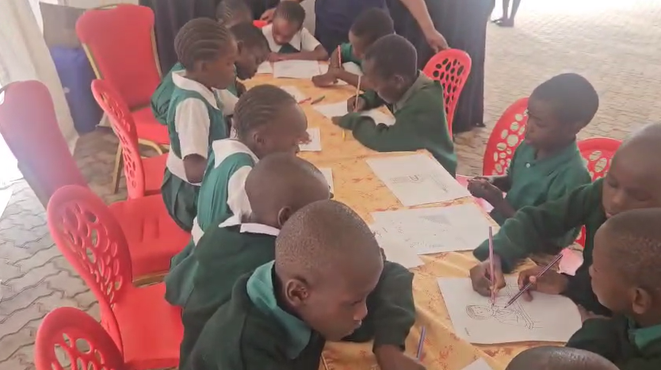
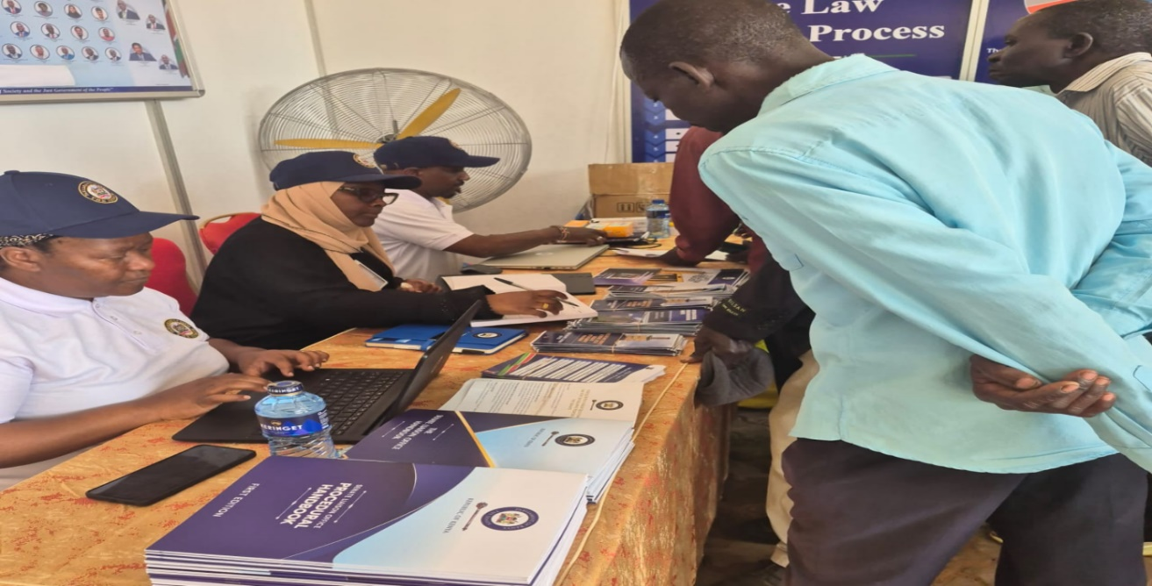
CHAPTER 6

6.1 CORPORATE SOCIAL RESPONSIBILITY (CSR) BY KEWOSA

The Kenya Women Senators Association (KEWOSA) successfully executed four side events during the Fourth Senate Mashinani sittings in Busia County. Key activities included implementing the Dignified Learning Initiative across seven schools, where over 2,000 students received dignity kits. KEWOSA also hosted consultative forums with local and regional women leaders and community members to address the Triple Threat (Early Teen pregnancy, HIV/AIDS, and Sexual Gender Based Violence (SGBV) and strengthen women's political representation. Challenges included securing adequate donor support for dignity packs and navigating tight member schedules. Recommendations focus on increasing the event budget and engaging social media influencers.

As part of the outreach program, the Kenya Women Senators Association (KEWOSA), with support from the National Syndemic Disease Council (NSDCC), organised several side events. These activities were designed to address key social and political issues within the county and involved collaboration with the Busia County Assembly Women Caucus.

The scheduled activities were as follows:

No. | Time | Activity
Monday, 6th October, 2025

 | 7:30 am – 1:00 pm | Visit to St. James Nasewa School, (Indoli, Lung’a, Buyama and Nasewa Junior Secondary Schools)  St. James Kwangamor Secondary School, and Okisimo Junior Secondary School
 | 2:00 pm – 3:00 pm | Engagement between KEWOSA and Busia County Assembly Women Caucus
 | 3:30 pm – 5:00 pm | Meeting with Community Leaders
Wednesday, 8th October, 2025

 | 7:30 am – 9:00 am | Regional breakfast meeting with women MCAs from Busia, Bungoma, and Siaya County

The side events were attended by twelve KEWOSA members, led by the Chairperson, Sen. Veronica Maina, MP as listed below:
1. Sen. Veronica Maina- Chairperson (Team Leader: Team A)
2. Sen. Catherine Mumma, MP (Team Leader: Team B)
3. Sen. Beth Kalunda Syengo, MP
4. Sen. Miraj Abdirahman, MP
5. Sen. Maureen Tabitha Mutinda, MP
6. Sen. Mariam Sheikh Omar, MP
7. Sen. Joyce Chepkoech Korir, MP
8. Sen. Beatrice Akinyi Oyomo, MP
9. Sen. Betty Batuli Montet, MP
10. Sen. (Prof) Margaret Kamar, EGH, MP
11. Sen. Agnes Muthama Kavindu, MP
12. Sen. Consolata Nabwire Wakwabubi, MP

Stakeholder Engagement

KEWOSA involved Busia County leaders, including Governor Hon. (Dr.) Paul Nyongesa Otuoma, Senator Okiya Omtata, MP, Women Representative Hon. Catherine Omanyo, MP, Teso South MP. Hon. Mary Emmase Otucho, all women MCAs from the Busia County Assembly. The aim was to ensure Busia County leadership was well represented and actively involved in the various KEWOSA activities during the Senate Mashinani week.

Other participants in the side events included the Chief Magistrate of Busia Law Courts, Hon. Edna Nyaloti; the County Commissioner; County Executive Committee Members for Health Services and for Gender, Culture, and Social Services; Sub-county Police Commissioners and Deputy County Commissioners; Women Chiefs; Busia Menstrual Hygiene Champion and the Chairperson of Community Health Promoters.

Secretariat’s Role
The Secretariat's role was comprehensive, including:
  - Sending invitations and coordinating with partners (NSDCC) to mobilise resources for dignity kits.
  - Consulting with the Busia County Women’s Caucus and KEWOSA to identify schools and prepare a comprehensive program.
  - Coordinating transport, managing publicity materials, and coordinating the Public Communication and Media teams.
  - Preparing press releases, a Chamber statement, and feedback slips from students of the various schools and the Women MCA’s.
Detailed Event Activities

Planning and Execution of KEWOSA Side Events (5th – 8th October, 2025)
The execution of the KEWOSA side events during the Senate Mashinani program in Busia County involved meticulous planning, school visits, and three key consultative meetings.
Preparatory Activities (5th October, 2025)
Reconnaissance Visit: The KEWOSA Secretariat and an official from the National Syndemic Disease Council (NSDCC) conducted a reconnaissance visit to the hosting schools to assess preparedness. They were received by teachers and inspected sites designated for tent setup and tree-planting activities.

Virtual Meeting: Later that evening, the NSDCC led a virtual meeting with all KEWOSA members and the secretariat. The session reviewed key issues and statistics from the Triple Threat data pack for Busia County, focusing on early teen pregnancy and sexual and gender-based violence (SGBV).

School Visits and Dignified Learning Initiative (6th October, 2025)
Delegation: On 6th October, KEWOSA members, the Busia KEWOSA caucus, the Busia County Senator and Women Representative, the Teso South MP, the KEWOSA secretariat, and NSDCC officials conducted early morning visits to the selected schools. The teams departed from the Busia County Assembly at 7:30 a.m., utilising two coaster buses and several Prado vehicles for transport.

Split Visits: The delegation split into two groups to cover the schools simultaneously.
    - Group 1 (Led by Sen. Veronica Maina) visited St. Joseph Kwang’amor Secondary School and Okisimo Secondary School, located approximately 39km from the County Assembly.
    - Group 2 (Led by Sen. Catherine Mumma) visited St. Joseph Nasewa Secondary School, approximately 25km away from the County Assembly.

Initiative Focus: KEWOSA implemented the “Dignified Learning” initiative in the mixed schools, which focused on menstrual health education, addressing period poverty, preventing SGBV, promoting hygiene, and empowering students to stay in school.
Resource Distribution: Approximately 2,000 students were distributed dignity kits. The kits were sourced through contributions from KEWOSA members, the Busia County Assembly Women Caucus and the NSDCC.

Other Activities: A tree-planting exercise was conducted with seedlings donated by the County Executive and coordinated through the Busia County Assembly Women’s Caucus, followed by a media briefing.

Consultative and Support Meetings (October 6 and 8, 2025)
Working Lunch: Following the school visits, KEWOSA, NSDCC officials, and the Busia Women’s Caucus held a working lunch hosted by Senator Okiya Omtatah, MP, at 1 p.m. in his residence.

Community Leaders Meeting (October 6): In the afternoon, KEWOSA and the Busia Women’s Caucus met with community leaders at PCEA Church in Busia Town 16. Attendees were drawn from across Busia County and included the Chief Magistrate, County Commissioner, various CECs, police, Women Chiefs, bodaboda representatives, religious leaders, teenage mothers, and young boys.

The highly engaging meeting focused on addressing the Triple Threat. Chief Magistrate Hon. Edna Nyaloti reaffirmed the Judiciary’s commitment to combating this issue among teenagers.

Some key legislative proposals that emerged from this meeting include:
- Establishment of safe spaces and adequate funding on these safehouses so that victims are protected from victimization and also have a place to go incase the perpetrators of these actions are close family.
- Provide a system for compensation and reparations from offenders to the victims.
- Ensure that the police adequately protect evidence that has been gathered to aid the prosecution's case.
- Bi- lateral agreement with Uganda to ensure perpetrators who relocate to Uganda, can be repatriated into the country to face the full force of the law.
- Introduction of video- link and recorded evidence so that victims and witnesses can provide evidence in court without the fear of facing their perpetrators.
- Banning of kangaroo courts on matters SGBV and early teenage pregnancy so that due process is followed and victims get a fair recourse in court.

Regional Women Leaders Meeting (8th October): A regional breakfast meeting was held at Breez Hotel, Busia County, from 7:30 a.m. to 9:00 a.m. Participants included women Members of the County Assembly (MCAs) from Busia, Bungoma, and Siaya counties. The event was graced by Governor Hon. (Dr.) Paul Nyongesa Otuoma, EGH.
- The Speakers encouraged participants to strengthen women’s representation in leadership at all levels.
- The Speakers emphasised the need to strengthen and safeguard devolution weighing in on the crucial role that women MCAs can play in enhancing women’s grassroot political participation.
- The Speakers further discussed how women can break barriers in the political space especially in conservative cultures.

Financial Contribution: KEWOSA members contributed Kshs. 45,500 towards purchasing groceries and diapers for one victim of SGBV and three teen mothers.

Key Achievements of the KEWOSA Side Events

The Kenya Women Senators Association (KEWOSA) successfully executed its side events during the Senate Mashinani program in Busia County, achieving the following outcomes:
- High Attendance and Engagement: Full and timely attendance was recorded by KEWOSA members, Busia County leadership, and all invited guests at the scheduled events.
- Dignified Learning Initiative: Dignity kits were successfully procured and distributed to over 2,000 students with support from various partners.
- Effective Consultative Forums: Consultative and engaging meetings were organised with KEWOSA, local leaders, and regional leadership. These meetings focused on addressing the Triple Threat (early teen pregnancy, HIV/AIDS, and SGBV) and discussing women’s leadership challenges and experiences.
- Communication Support: Chamber and press statements were prepared in a timely manner.
- Logistical Efficiency: Transport logistics for members to and from the event venues were coordinated efficiently.
- Adequate Venues: Spacious meeting spaces were secured for all the side events.

Challenges and Recommendations

Challenge | Recommendation
Limited donor support for dignity packs. | Increase the procurement budget for KEWOSA’s Senate Mashinani activities to ensure an adequate event budget for the side events.
Tight schedules, conflicting with members’ committee sittings and chamber sessions. | Schedule meetings with adequate time to allow members to participate fully without conflicting commitments.
Limited visibility of KEWOSA’s social media posts for the side events. | The Planning Committee should engage social media influencers to enhance visibility and online engagement for future events.
Limited resources, including few gifts for guests and inadequate drinking water during school visits. | Increase the procurement budget for KEWOSA’s Senate Mashinani activities to ensure adequate funding for the side events.

6.2 FOOTBALL MATCHES

The Busia Senate Mashinani curtain-raiser was a friendly football match between the Bunge Football Club and the Members of Busia County Assembly held on Sunday 4th October, 2025 at Mundika Boys Primary School. The Members of the County Assembly won 4-2 against Bunge Football Club.

The Bunge Football Club also held a friendly match against the Obulala Football Club on 10th October, 2025 at Mundika Boys Primary School. Bunge Football Club won 1-0 against Obulala Football Club.

The total cost of the two tournaments was Kshs144,529. The table below highlights a breakdown of costs incurred –

S/NO | ITEM | COST (KSH)
1. | Tents and decoration, chairs, decoration, lime used to mark the field, field marking labour, nets and corner flags, MC’s, ball boys, referees, host, obulala organisers and toiletries | 74,100
2. | Refreshments for players, guests and senate staff (water, juice, glucose) | 103,609
3. | Trophies and Awards | 12,180
4. | Medication for players | 32,040
5. | Laundry | 13,600
6. | Hiring an Ambulance | 48,000
GRAND TOTAL |  | 283,529

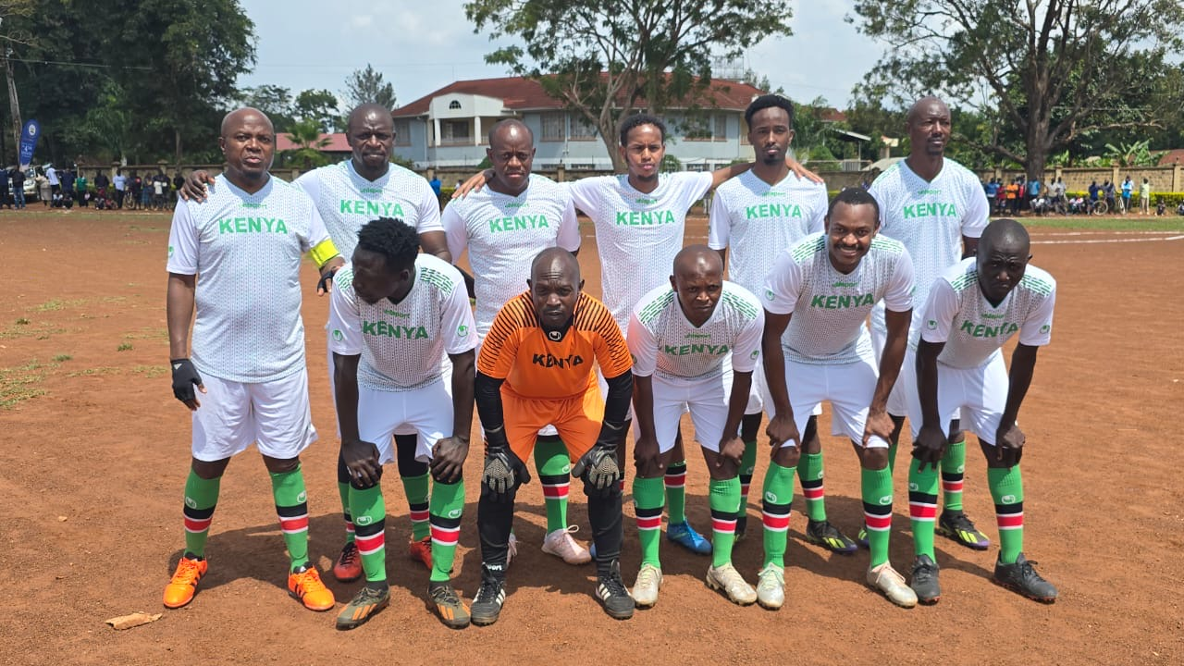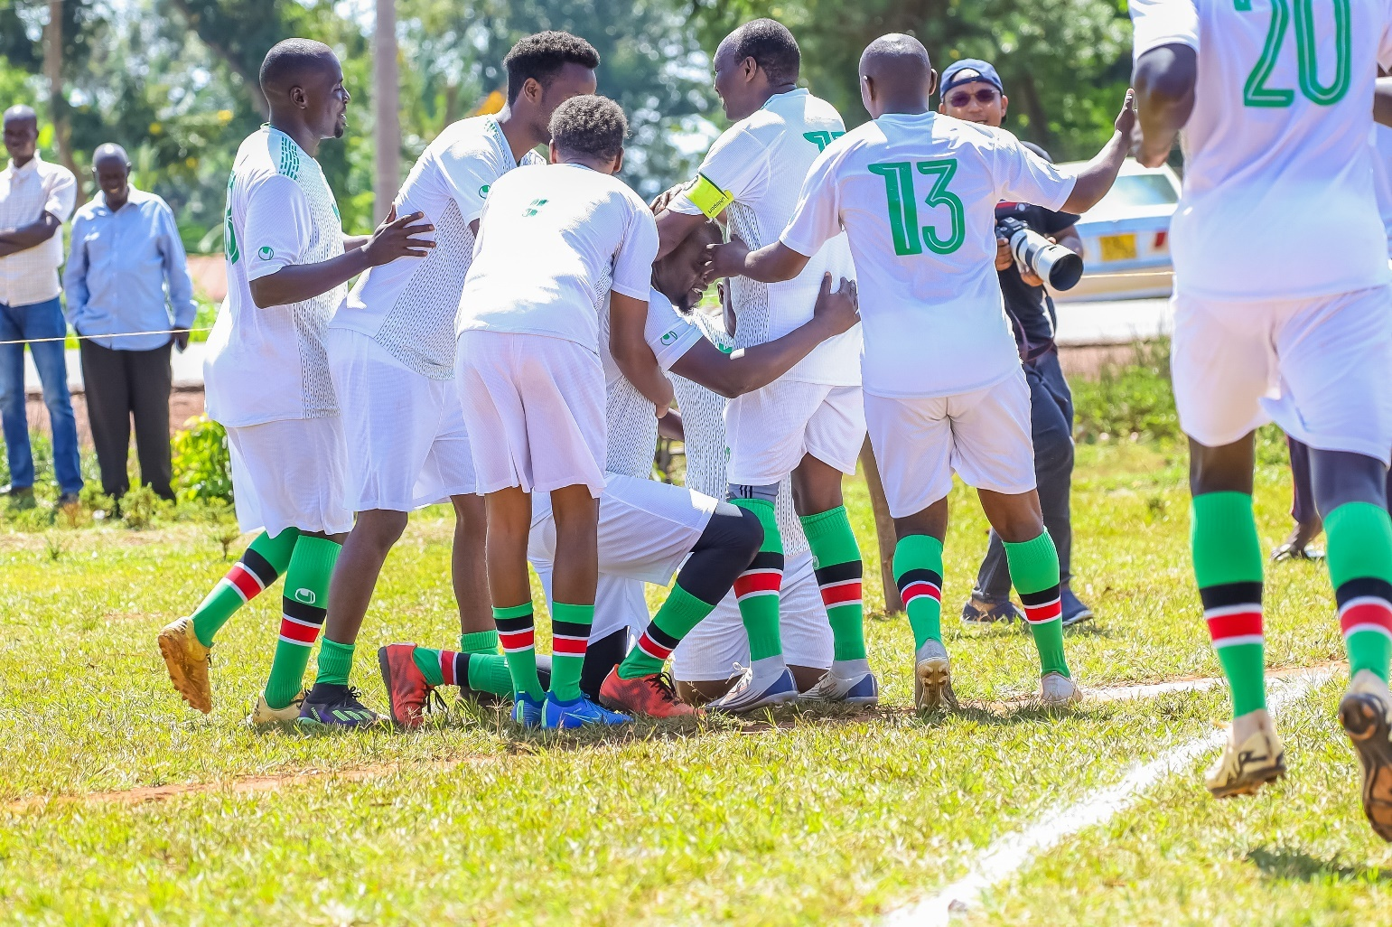

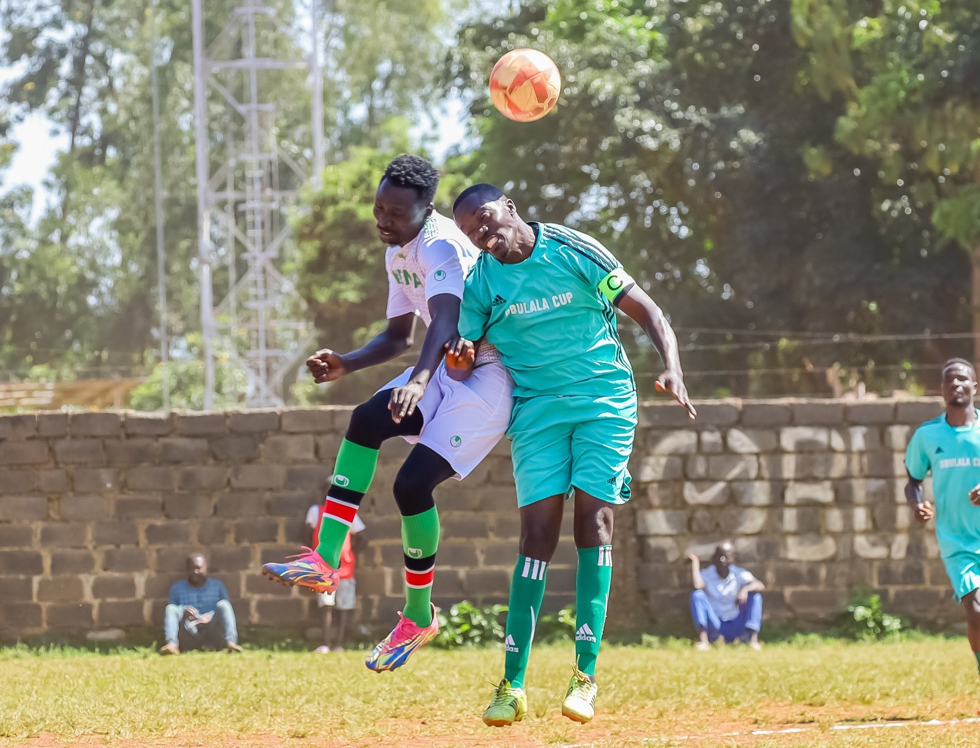

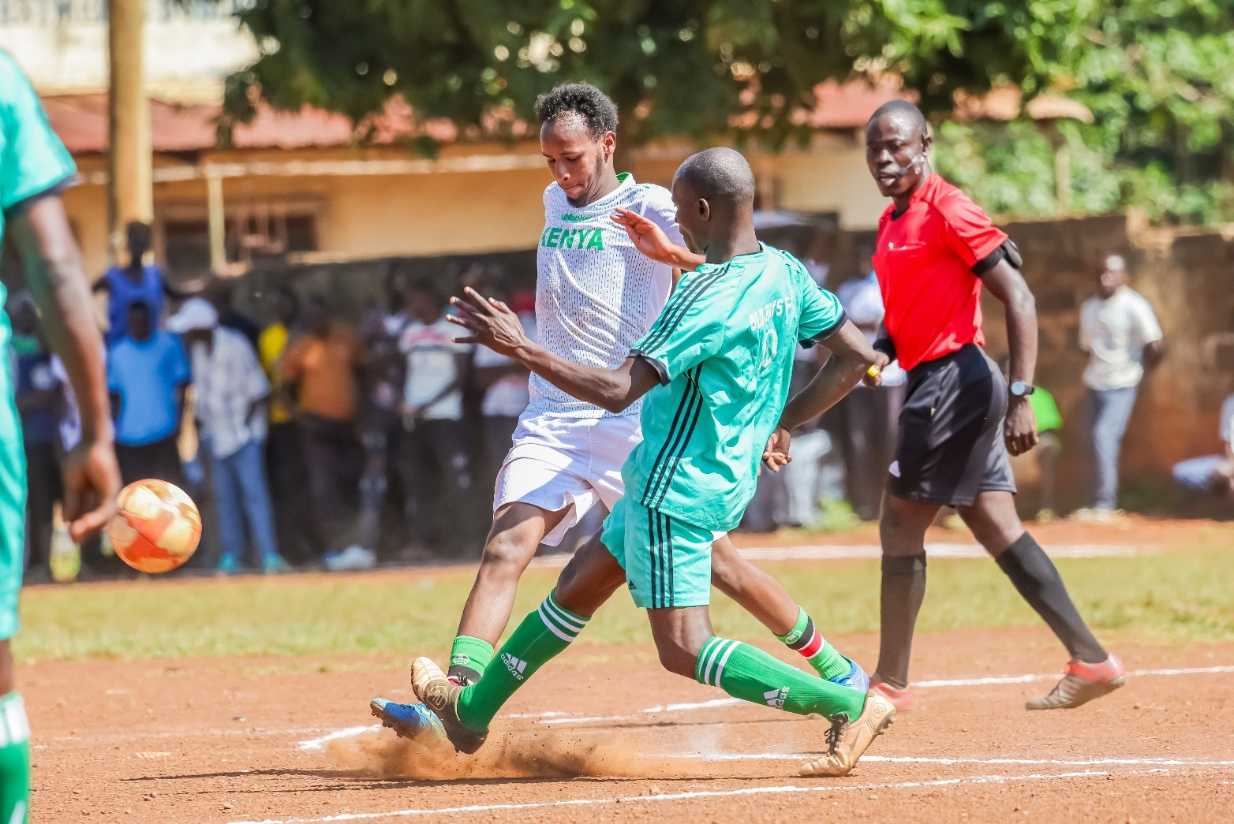
CHAPTER 7

SECURITY

The Senate Mashinani was held in the Busia County from 6th to 10th October 2025. This report highlights the preparatory activities, security arrangements, logistical support, challenges experienced, and overall observations relating to security and safety management during the event.

PREPARATION AND ADVANCE VISIT

An advance team comprising members of the Planning Committee travelled to Busia ahead of the activity to assess and prepare the facilities. The following preparatory measures were undertaken:
- General cleaning of the Assembly premises was conducted using staff from the County Assembly and hired casuals.
- Due to the extensive workload and accumulation of obsolete items within offices and corridors, casual labourers were hired to assist in thorough cleaning and clearance to create an ambient environment for the Senate activities.
- The Busia County Government, through the Municipal Manager, provided a water bowser to support the cleaning exercise.
- A specialized cleaning service provider was contracted to clean the Chamber and leadership offices due to the need for appropriate cleaning equipment and expertise.
- The Senate also procured consumables such as detergents, handwashing soap, tissue papers, and sanitizers for use in lavatories throughout the event.
- Renovations were done inside the Chamber to bring to the Standard required by the Senate.
- An expenditure of Kshs. 200,000 was incurred in facilitating the cleaning exercise and provision of consumables for duration of the event.

SECURITY ARRANGEMENTS

Comprehensive security coverage was provided jointly by the following teams:
The Senate SAA officers, Parliamentary Service Commission (PSC) Security Officers National Police Service (NPS) comprising the General Service Unit (GSU), DCI, APS, Traffic Police, K9 Ministry of Interior through County Administration, and National Intelligence Service (NIS), County Assembly SAA and Security Officers.

Security operations were maintained on a 24-hour basis throughout the event to ensure safety of Senators, staff, visitors, and the facilities in use.

A total of 117 officers drawn from the Kenya Police Service (KPS), Administration Police Service (APS), Directorate of Criminal Investigations (DCI), General Service Unit (GSU), Traffic Police, K9, NIS, and Ministry of Interior participated and were duly facilitated by the Senate.
The total expenditure for security facilitation amounted to Kshs. 117,000,000.

Additional measures included:
- Deployment of armed police escorts to all Senate committees and delegations conducting field visits.
- 24-hour security guarding at all hotels hosting Senators and staff.
- Robust screening procedures for all persons, vehicles, and luggage entering the Assembly premises.
- Bomb sweeps were performed by K9 at all venues used by the Senate during the function

CHALLENGES EXPERIENCED

Despite the overall success of the event, several challenges were encountered:

- Inadequate cleaning services and supplies by the County Assembly— including shortages of detergents, toilet paper, and handwashing soap.
- Accumulation of obsolete items in offices and corridors that required hiring of casuals to clear before operations began.
- Tensions between staff from the offices of the Governor and the Senator of Busia, which at times became acrimonious. Security personnel intervened promptly to prevent escalation.
- Malfunctioning lift in the Assembly Tower, which stalled on several occasions and temporarily trapped users inside.
- Limited space within the assembly campus, leading to occasional rowding due to the high number of activities.
- Transport-related agitation among some Senators who had opted for mileage reimbursement instead of full per diem payments, and later demanded individual vehicles upon arrival at Kisumu Airport.
- It was difficult to provide security to the Senators who organized and took accommodation in facilities that were not recommended by the Senate Board of Management and the Senate Business Committee.

GENERAL OBSERVATIONS
- Coordination between Senate SAA, County Assembly SAA, PSC Security, and National Security agencies was commendable.
- The cooperation of the Busia County Government (the assembly and executive) in logistical support was appreciated.
- Security response was timely and effective in all instances, maintaining a peaceful and conducive environment.
- Despite minor logistical hitches, the overall execution of Senate Mashinani in Busia was successful.

CONCLUSION

The Senate Mashinani sitting in Busia County was generally successful with minimal security or operational disruptions. The collaborative efforts of all security organs, Senate staff, and County Government ensured a safe and orderly environment for legislative activities.
Continuous improvement is, however, recommended in the following areas:
- Facility maintenance and cleaning arrangements;
- Coordination of local government personnel to create synergy and unity of purpose;
- Clarification of transport and facilitation arrangements for Senators; and
- Early logistical planning to address infrastructure limitations.

CHAPTER 8

HOSPITALITY

The main mandate of the Hospitality Department was to liaise with the procured service provider and develop the most effective approaches to deliver hospitality services to Honourable Senators, Members of the Busia County Assembly, invited guests, Senate staff, and County Assembly staff.

The hospitality services provided at the Busia County Assembly included the provision of 9:00 a.m. and 4:00 p.m. running teas for Honourable Senators at the Members’ Lounge and committee rooms, Members of the Busia County Assembly, Senate staff, County Assembly staff, and invited county leadership appearing before the Senate Committees. Lunch was also provided for Honourable Senators, Members of the Busia County Assembly, Senate staff, County Assembly staff, and invited county leadership appearing before the Committees.

All hospitality services were outsourced to a professional outside caterer, preferably one operating a minimum 4-star hospitality facility within Busia County, supported by a few hospitality staff from Parliament to assist in production and service delivery. The Procurement Team engaged Itoya Hotel to provide teas and lunches for Senators and staff during the sittings in Busia County.

The service provider, M/S Itoya Hotel, in collaboration with the Senate’s Catering Department, coordinated the provision of meals for approximately 800 persons, as well as the dinner hosted by the Clerk of the Senate upon the conclusion of the Sittings. Teas and lunches for Senators and staff were served in tents pitched at the parking yard and at the Archives Building opposite the Assembly, respectively. The total cost incurred for the provision of these hospitality services amounted to Kshs. 16,337,556.00.

- Teas and Lunches

 | DATE | LUNCH | 10.00 AM TEA | 4.00 PM TEA
1. | 06/10/2025 | 580 pax | 500 pax | 500 pax
2. | 07/10/2025 | 730 pax | 500 pax | 500 pax
3. | 08/10/2025 | 800 pax | 500 pax | 500 pax
4. | 09/10/2025 | 800 pax | 500 pax | 500 pax
5. | 10/10/2025 | 300 pax | 500 pax | 500 pax

- Water and Assorted Beverages

 | WATER & BEVERAGES | QTY
1. | Water | 7240 Bottles
2. | Assorted juices/ sodas | 2000 Litres

The table below tabulates the all the procurable items -

QTY | ITEM DESCRIPTION | DAYS
1 | Aluhall Tent Draped: 15m*25m | 4
1 | Aluhall Tent Draped: 15m*25m (Drapery) | 4
1 | Hexagonal Tent 6*6 (Cleaning Tent) | 4
160 | Louis Chairs | 4
20 | Round Table (Dressed senate colors) | 4
15 | Rectangular oblong tables (buffet set-up) | 4
20 | Centre pieces flowers | 4
2 | Pedestrial flowers with stands | 4
12 | Potted plants | 4
8 | Floodlights | 4
2 | Chandeliers (Big) | 4
375sqm | Blue carpet | 4
100m | Long Extension cable | 4
300 | Buffet Luncheon - Monday | 1
500 | Buffet Luncheon - Tuesday | 1
500 | Buffet Luncheon - Wednesday | 1
500 | Buffet Luncheon - Thursday | 1
200 | Buffet Luncheon - Friday | 1
5000btls | Keringet Mineral Water 500ml | 5
2000ltrs | Fresh Juices/sodas | 5
150 | Welcome Cocktail hosted by CoS | 1
150 | Dinner hosted by the SSN | 1
250 | Closing Cocktail hosted by the CoS | 1
10 | Lounge set | 4
2 | Lounge coffee stools | 4
2 | Rectangle oblong tables
6 | Potted flowers | 5
108sqm | Red carpet (Walkways) | 5
1 | Red carpet | 5
1000 | Committees’ teas - 10 O’clock, 4 O’ Clock tea/ snacks | 5
6 | Hexagonal Tent 6*6 | 5
20 | Round table (Dressed) | 5
12 | Rectangular oblong tables (Dressed) | 5
200 | Spider seats | 5
8 | Floodlights | 5
6 | Tunnel tent | 4
6 | Tunnel tent (Drapery) | 4
12 | Working tables (Dressed) | 4
40 | Banquet seats | 4
505sqm | Blue carpet | 4
2 | Flood lights | 4
1 | Tunnel tent | 4
1 | Tunnel tent (Drapery) | 4
15sqm | Profloor | 4
15sqm | Blue carpet | 4
1 | Gold chrome cocktail table | 4
2 | Gold chrome cocktail stools | 4
2 | Pedestrial flowers with stands | 4
1 | Chandelier: small | 4
1 | Signage sticker | 4
1 | Curved tent 10*30 (Outreach) | 4
1 | Hexagonal tent 6*6 (PWD’s) | 4
120 | Spider seats | 4
336sqm | Blue carpet | 4
2 | Chandeliers: small | 4
4 | Flood lights | 4
7 | Lounge seats - single | 4
7 | Coffee stools | 4
1 | Small raised stage | 4
5 | Rectangular oblong tables(dressed) | 4
4 | Pedestrial flower with stands | 4
20 | Long Rectangular oblong tables dressed (Committee’s) | 3
135 | Spider seats | 3
1 | Double peak tent | 3
10 | Cocktail table | 3
3 | Centre piece flowers | 3
24 | Rectangular oblong tables (dressed senate colors) | 4
40 | Banquet seats | 4
1 | Executive Trailer Toilet (Luncheon Area) | 5
1 | PWD Executive Trailer Toilet (Lounge) | 5
2 | Porta Loos (PR) | 5
15 | Dust bins | 5
3 | Hexagonal Tent 6*6 covering VIP | 5
1 | Transport & logistics | 5

A visit was conducted to various hospitality facilities to evaluate their capacity to deliver four-star services for the dinners and cocktails hosted by the host Senator, Speaker of the Senate and the Clerk of the Senate during the sittings period. The assessment focused on key areas including the quality and adequacy of equipment, menu variety, overall hygiene and cleanliness standards, as well as staff capacity in terms of professionalism, training, and service delivery. Observations gathered from these visits were used to guide recommendations on which establishments met four-star requirements and to identify areas requiring improvement for full compliance.

The following hospitality facilities were visited:
- Hotel Itoya
- Grand Brystal Comfort Inn
- Lubiri Hotel
- Annex Chef West Hotel
- The Breeze Hotel
- Farm View Hotel
- Chef West Hotel
- Lympo Resort

From the list above, the hotel facilities that met the standards required for accommodation of Honourable Members were Lubiri Hotel, Grand Brystal Comfort Inn, and Hotel Itoya.

- Dinner and Enhanced Cocktail

 | DINNER | VENUE | NUMBER OF ATTENDEES | TOTAL COST (KSH)
1. | Senator’s dinner | Grand Brystal Comfort Inn | 150 | 1,050,000.00
2. | Speaker’s dinner | Lubiri Hotel | 150 | 900,000.00
3. | Clerk of the Senate’s dinner | County Assembly | 500 | 2,656,150.00

The main duties of the Hospitality Services Team during the Senate Mashinani sittings were to:
- Liaise with hotel management to secure designated areas near the venue for the seamless provision of hospitality services to Honourable Senators and Senate staff;
- Collaborate with hotel management in developing appropriate daily menus that catered to the tastes and preferences of the clientele;
- Supervise the setup of both Members’ and staff makeshift restaurants in readiness for lunch service;
- Ensure that the 10:00 a.m. tea, lunch service, 4:00 p.m. tea, and other refreshments were served on time;
- Participate in the planning and execution of dinners and cocktails hosted by the Rt. Honourable Speaker and the Clerk of the Senate;
- Oversee the actual production of food to ensure that it met the required quality and standards; and
- Ensure value for money in all activities relating to the provision of hospitality services.

The Planning Committee nominated thirteen (13) hospitality officers to coordinate hospitality services for approximately 800 persons during the five days of the Senate Mashinani sittings in Busia County, held from 6th to 11th October, 2025.

The breakdown of 800 persons was as follows:
- Senators and invited guests – 100 pax
- Members of the County Assembly – 54 pax
- Senate staff – 330 pax
- Busia County Assembly staff – 120 pax
- Drivers, bodyguards, and media – 200 pax

The Hospitality Department ensured that all guests received exceptional service, reflecting the Senate’s commitment to quality and excellence in service delivery.

The presence of the Hospitality Team greatly contributed to the successful coordination of catering services. The 10:00 a.m. and 4:00 p.m. teas and snacks at the various designated areas were served on time, and lunches were also served promptly. The Rt. Honourable Speaker’s enhanced dinner and cocktail were well organized and executed on schedule. The team further assisted in serving at the high table, while catering services for Members were separated from those for other participants, thereby reducing movement and minimizing interference. The coordination between the Hospitality Team and hotel staff proved highly effective, as the hospitality staff were well conversant with the needs of Honourable Members, which enhanced the overall dining experience and gave Members confidence in the services provided.

During the sittings, the main challenge encountered was the unauthorized patronage of designated restaurant areas by unapproved clients. This issue arose from a lack of collaboration between the Sergeant-at-Arms and the Hospitality Team on seating management arrangements.

To enhance the success of future events, closer collaboration between the event planning organizers and the Hospitality Team from the initial stages is highly encouraged. This will help address issues related to menu planning, restaurant setup, and other logistical challenges. The deployment of additional hospitality staff, both in service and production, is also recommended for future Senate events. Furthermore, the mode of transportation for the Hospitality Team should be adequately planned and facilitated during future Senate Mashinani sittings to ensure efficiency in service delivery.

The service provider and the total cost for the provision of services are as indicated below –

 | Service Provider | Description of Item | Total Amount (Ksh)
 | Itoya | Outside Catering Services during Senate Mashinani | 25,617,556.00
 | Grand Brystal Comfort Inn | Senator’s Dinner | 1,050,000.00
 | Lubiri Hotel | Speaker’s Dinner | 900,000.00
Total |  |  | 27,567,556.00

CHAPTER 9

TRANSPORT TO AND FROM BUSIA
Busia County Assembly is accessible by both road and air through Kisumu International Airport. Although the distance between Busia County Assembly and Nairobi is approximately 453 km, the road network is good and easily navigable. The drive from Kisumu International Airport to Busia County Assembly, covering approximately 115 km, takes about two hours.
Subsequently, the Senate Board of Management (SBOM) resolved that a memo be issued to all Senators requesting them to select their preferred mode of transport to Busia County from Nairobi, as follows:
- Be facilitated with air tickets to Kisumu, after which each Senator would use one Prado vehicle for road transport to Busia;
- Approval be granted for Senators wishing to use their private vehicles to do so, and to claim mileage equivalent to that claimed by the Senator for Busia County, thereby eliminating the need for hiring vehicles in Busia; and
- Senators in leadership positions be facilitated to use their official vehicles while in Busia and be provided with air tickets, in addition to full per diem for their official drivers and bodyguards.
The primary mode of transport for staff traveling to and from Busia was by road. However, a few exceptions were made for members of the Senior Board of Management and staff on Scale 12 and above, who were facilitated with flights to Kisumu International Airport and Prados to and from Busia County.
Road travel was supported through the procurement of vehicles that ferried staff from Nairobi to Busia. Sixteen (16) Coaster buses, thirty (30) Prado vehicles, five (5) Coaster buses, seven (7) vans, and one (1) truck were sourced from Nairobi, which helped ease logistical challenges.
The table below provides a breakdown of air travel costs incurred –
PROCUREMENT OF AIR TRANSPORT
S/No | Description | Total
1. | Advance Team | 1,480,200.00
2. | Second Team  - Senators  - Staff | 2,136,950.00
SUB-TOTAL |  | 3,617,150.00
The table below provides a breakdown of costs incurred in hiring vehicles used for ground transport –
PROCUREMENT OF GROUND TRANSPORT
S/No | Description | Qty | Days | Rate | Total
1. | Hire of Coaster Bus for Bunge Sports Club Team | 1 | 9 | 45,000.00 | 405,000.00
2. | Hire of Coaster Buses for Senate Staff | 15 | 8 | 45,000.00 | 5,400,000.00
3. | Hire of 4x4 Toyota for the Office of the Speaker | 2 | 6 | 38,000.00 | 456,000.00
4. | Hire of van for use by PBU | 1 | 3 | 28,000.00 | 84,000.00
5. | Hire of van by advance team | 1 | 14 | 28,000.00 | 392,000.00
6. | Hire of vans by advance team | 3 | 11 | 28,000.00 | 924,000.00
7. | Hire of 4x4 Toyota for the advance team | 1 | 11 | 38,000.00 | 418,000.00
8. | Hire of vans by advance team | 2 | 9 | 28,000.00 | 504,000.00
9. | Hire of truck to and from Busia | 1 | 2 | 200,000.00 | 400,00.00
SUB-TOTAL |  |  |  |  | 8,983,000.00
16% VAT |  |  |  |  | 1,437,280.00
TOTAL COST INCLUSIVE OF ALL TAXES |  |  |  |  | 10,420,280.00

CHAPTER 10

ACCOMMODATION

Senators were given the option of either being provided with full per diem or quarter per diem while being accommodated on a half-board basis. The majority of the staff complement were provided with full per diem, except for staff in Scale 7 and below, who were provided with quarter per diem and accommodated on a half-board basis.

The Board further resolved that the Rt. Hon. Speaker be accommodated at Lubiri Resort and that two rooms be reserved for staff.

The table below highlights the hotels that were engaged to provide half-board accommodation for Senators and staff for five (5) nights –

S/No. | Half Board Accommodation | Hotel | Total (Kshs.)
 | 13 | M/s Lubiri Holdings LTD | 1,105,000.00
 | 60 | M/s Great Chef Hotel Ltd | 3,236,400.00
 | 30 | M/s Itoya Hotel | 1,790,112.00
 | 20 | M/s Grand Brystal Comfort Inn | 800,000.00
TOTAL |  |  | 6,931,512.00

EXPENDITURE STATUS OF SENATE MASHINANI IN BUSIA COUNTY

The table below presents a summary of all service providers contracted along
with the corresponding expenses, for items procured to support the sittings of the
Senate in Busia County –

S/N | Goods/Service Description | Service Provider | Price (KSHs)
1. | Transport (Air travel) | Tondwe Africa Group (Jambojet)  Kenya Airways | 239,295  3,617,150
2. | Ground Transport | Nguvu Suppliers  (Nairobi) | 18,287,400
3. | Accommodation | Hotels in Busia County | 6,969,096
4. | Payment of per-diems | - | 8,000,000
6. | Supply and delivery of ICT  equipment & related accessories | M/S Capital Communication Solutions International Limited | 2,963,050
7. | Supply and Delivery of 200 mbps Bandwidths and Wireless mifi 5G Connectivity Services during Senate Mashinani | M/S Capital Communication Solutions International Limited | 384,772
8. | Design, Supply and Delivery of Branded Items | M/S Ultimate Supplies Limited | 2,989,000
9. | Refurbishment of Busia  Assembly Chamber | M/S Turks Consultants Limited | 4,427,970
10. | Supply and Delivery of Speaker’s Seat for donation to the County Assembly of Busia | M/s Kenya Prison Services | 140,000
11. | Supply and Delivery of One Set of Laws of Kenya | M/s Law Africa Publishing Limited | 496,000
14. | Procurement of event management items  (furniture, tents) | Hotel Itoya | 1,659,496
15. | Procurement of outside catering services (teas, lunches and  dinner/cocktails) | Hotel Itoya | 25,617,556.00
17. | Live coverage | Kenya Broadcasting Corporation | 5,374,048
TOTAL (KSHs.) |  |  | 81,164,833

SUCCESSES FROM THE SENATE SITTINGS IN BUSIA COUNTY

Objective 1: Promote the role and work of the Senate and enhance public

awareness regarding the Business of the Senate and Parliament in general

- The Senate and its Committees successfully took Parliamentary proceedings closer to the people. Through the open plenary sittings, public engagement forums, outreach programmes and media engagements, residents were able to directly observe Senate deliberations and gain insight into legislative processes, oversight responsibilities, and the Senate’s mandate in safeguarding devolution. Senators engaged with county leaders, community groups and different stakeholders providing an opportunity for citizens to raise issues, seek clarification, and participate in governance discussions.

- Extensive live media coverage, Corporate Social Responsibility (CSR) programs and civic education activities further increased awareness of the Senate’s work across the county and the region. These engagements contributed to improved public appreciation of the Senate’s role in national development, accountability, and representation, thereby achieving the objective of strengthening parliamentary visibility and civic participation.

Objective 2: Highlight existing and new opportunities for engagement in the legislative process

- The Senate sittings were attended by various dignitaries and leaders from the host and neighboring counties, fostering a robust exchange of ideas and strengthening intergovernmental relations. These interactions created opportunities for collaborative legislative initiatives, provided an opportunity for mutual engagement in the law-making process, and promoted a shared understanding of regional priorities.

- Committee meetings, stakeholder engagements and public forums allowed residents, civil society groups and even youth representatives to share their views and learn how to submit petitions, present memoranda, and participate in policy discussions. Through civic education initiatives, media coverage, and direct interaction between Senators and the public, the sittings provided a real-time learning experience on legislative engagement. This increased awareness of formal participation channels and motivated greater involvement in future parliamentary processes.

Objective 3: Develop and strengthen partnerships at the county level of government

- Senators and Members of the County Assembly participated together in various committee meetings, fostering networking and enhancing the capacity of County Assembly members. The sittings also created an avenue for strengthened partnerships with county governments through direct engagement with officials and local leaders. These in effect established mechanisms for ongoing partnership and joint legislative initiatives.

Objective 4: Provide an opportunity to members and staff of county assemblies to learn and share best practices with Senators and parliamentary officers

- Senators were able to interact with Members of the County Assembly, fostering learning and the exchange of best practices.

- Senate staff were able to interact with the staff of the host County Assembly, both formally and informally. Through committee meetings, plenary sessions, and targeted engagements, staff gained insights into legislative procedures, oversight functions, and effective parliamentary operations. These interactions enhanced the capacity of county assembly members and staff, promoted professional development, and encouraged the adoption of innovative approaches to governance and service delivery.

- Informally, through the various side events including the dinner hosted by the Clerk of the Senate, networking of staff of the County Assembly and capacity building took place.

OTHER SUCCESSES

- Showcasing Busia County’s strategic role in cross-border trade.

- The sittings highlighted Busia as a key hub for trade and regional cooperation, drawing attention to development opportunities in infrastructure, cross-border trade, and investment.

- Focus on Sectoral Development Priorities. Sectors such as healthcare, education, agriculture, and infrastructure were discussed in detail, helping to align county and national development agendas.

- Promotion of Accountability. By reviewing county operations and budgets, the Senate reinforced oversight and accountability in governance at both national and county levels.

- Economic Boost for the Local Community. Local vendors, transport providers, hotels and service providers benefited from increased activity during the Senate sittings, contributing to Busia’s local economy.

- Enhanced security measures were implemented. This ensured a safe and conducive environment for the plenary proceedings and committee sittings, reflecting a commendable commitment to maintaining order and fostering a secure legislative space.

- Efficient and timely transaction of Senate business both in Plenary and Committees.

- Great leadership right from the planning level to the Senate Management. Facilitation was great and response to emergencies/requisitions was prompt.

CHALLENGES FROM THE SENATE SITTINGS IN BUSIA

- Cross-Border Trade Concerns. While trade issues were highlighted, addressing bottlenecks like customs delays, informal trade barriers, and border infrastructure limitations requires sustained follow-up.

- Coordination Among Stakeholders. Engaging multiple levels of government, community groups, and external agencies sometimes led to conflicts and delays in consultations.

- Public Expectations versus capacity of the Senate. Citizens often had high expectations for immediate solutions to local issues, which the Senate’s legislative and oversight role could not fully deliver on the spot.

- Connectivity and Technology Challenges. Internet and audiovisual issues affected live streaming and documentation in some instances.

- Underbudgeting. Some budgeted items during the Senate sittings did not fully meet the actual needs on the ground, resulting in emergency purchases. This highlights the need for more careful and flexible budgeting in future, including contingency provisions to address unforeseen expenses.

- Expectations from the host county. Some items procured and utilized during the Senate sittings were expected by the host county to remain in their possession after the event. This underscores the need for clear communication and prior agreements regarding which resources are for temporary use and which, if any, may be retained by the county.

FINAL RECOMMENDATIONS

- Provide civic education to the residents of the host county on the purpose and scope of Senate Mashinani prior to the sittings to manage their expectations.

- Procurement of reliable portable satellite internet to reduce dependency on fibre optic internet.

- Early and Clear Communication with Host Counties regarding items and resources that are for temporary use versus what can remain with the county.

- Strengthen outreach to local communities, civil society, and businesses to maximize participation.

- The Senate to identify areas of interest of a county in future Senate Mashinani and fund the CSR activities to be undertaken.

- The Senate to advocate and participate in tree planting activities in counties during Senate Mashinani, in support of the Government’s effort to reduce greenhouse emissions, stop and reverse deforestation and restore hectares of deforested and degraded landscapes.

- Plans for the next sittings of the Senate outside Nairobi to start early, with counties being notified and interested counties to write to the Senate showing their interest in hosting Senate Mashinani.

- Provision of adequate branded notebooks and pens to remain part and parcel of future Senate Mashinani branding.

- Monitoring and Evaluation. Establish mechanisms to capture feedback, document lessons learned, and follow-up actions after each Mashinani program. Track outcomes on citizen engagement, county partnerships, and legislative effectiveness.

ANNEXURE
LIST OF PARTICIPANTS
  - SENATORS
S/NO. | NAME
 | Sen. Amason Jeffah Kingi, MP
 | Sen. Kathuri Murungi, MP
 | Sen. Aaron Cheruiyot, MP
 | Sen. Abass Sheikh Mohamed, MP
 | Sen. Adan Dullo Fatuma, MP
 | Sen. Khalwale Boni, MP
 | Sen. Boy Issa Juma. MP
 | Sen. Cherarkey Samson, MP
 | Sen. Chute Mohamed Said, MP
 | Sen. Ekomwa James Lomenen, MP
 | Sen. Eddy Oketch, MP
 | Sen. Kisang William Kipkemoi, MP
 | Sen. Madzayo Stewart Mwachiru, MP
 | Sen. Mwinyihaji Faki, MP
 | Sen. Seki Ole Lenku
 | Sen. Joyce Korir, MP
 | Sen. Alexandar Mundigi, MP
 | Sen. Mungatana Danson Buya, MP
 | Sen. Joe Nyutu, MP
 | Sen. Moses Kajwang’, MP
 | Sen. Ogolla Beatrice Akinyi, MP
 | Sen. Okoiti Andrew Omtatah, MP
 | Sen. Omar Mariam Sheikh, MP
 | Sen. Osotsi Godfrey Atieno, MP
 | Sen. Recha Julius Murgor, MP
 | Sen. Kamar Margaret Jepkoech, MP
 | Sen. Betty Montet, MP
 | Sen. Catherine Mumma, MP
 | Sen. Esther Okenyuri, MP
 | Sen. Hezena Lemaletian, MP
 | Sen. Tabitha Mutinda, MP
 | Sen. Nyamu Karen Njeri, MP
 | Sen. John Methu, MP
 | Sen. Murango Kamau, MP
 | Sen. Oburu Oginga, MP
 | Sen. Mogeni Erick Okong’o, MP
 | Sen. Nderitu John Kinyua, MP
 | Sen. Joseph Kamau, MP
 | Sen. Miraj Abdulrahman Abdullahi, MP
 | Sen. Veronica Maina Waheti, MP
 | Sen. Consolata Wakwabubi, MP
 | Sen. Ledama Olekina, MP
 | Sen. David Wafula Wakoli, MP
 | Sen. Agnes Muthama Kavindu, MP
 | Sen. Enoch Wambua Kiio, MP
 | Sen. Johnes Mwaruma Mwashushe, MP
 | Sen. Mwenda Gataya Mo Fire, MP
 | Sen. Sifuna Edwine Watenya, MP
 | Sen. Syengo Beth Kalunda, MP
 | Sen. Tobiko Peris Pesi, MP
 | Sen. George Mbugua Mungai, MP
 | Sen. Wamatinga Wahome, MP
 | Sen. Thangwa Paul Karungo, MP

  - STAFF
OFFICE OF THE CLERK
S/NO. | NAME | DESIGNATION
 | Mr. Mohammed Ali Mohamed, MBS | Deputy Clerk
 | Ms. Eunice Gichangi, MBS | Deputy Clerk
 | Ms. Sophy Salamba | Senior Personal Secretary
 | Ms. Agnes Muchoki | Senior Executive Secretary
 | Ms. Fatuma Issa | Senior Personal Secretary
 | Ms. Jacklyne Okech | Personal Secretary
 | Mr. Ahmed Nasser | Office Administrator
 | Ms. Rita Chudi | Office Assistant
 | Ms. Nelly Mbuvi | Office Assistant
 | Mr. Roble Adan | Driver (Full Per diem)
 | Mr. Alfred Letemere | Driver (Full Per diem)
 | Ms. Josephine Galsaraco | Office Assistant
 | Mr. Kelvin Wandera | Office Assistant

OFFICE OF THE SPEAKER
S/NO. | NAME | DESIGNATION | SCALE
 | Mr. Benedict Furaha | Chief of Staff | 15
 | Ms. Dorcus Ambuto | Chief Public Communications Officer | 13
 | Ms. Lucianne Limo | Ag. Chief MRO | 13
 | Ms. Halima Maluki | Principal Research Officer | 12
 | Mr. Charles Ndegwa Githui | Personal Assistant (D.S Office) | 12
 | Ms. Karen Mbugua | PA (Deputy Minority Whip) | 12
 | Mr. Maricus Agutu | Principal, Media Relations Officer | 12
 | Ms. Silvia Wendoh | Research Officer (Majority Whip Office) | 12
 | Mr. Nancy Kawira | Senior Research Officer (D.S Office) | 11
 | Ms. Camille Pahe Kai | Legal Counsel (Minority Leader Office) | 11
 | Ms. Joyce Ngetich | Senior Research Officer, Commissioner Korir’s Office | 11
 | Ms. Sheena Monene | Commissioner Mogeni’s Office | 11
 | Mr. Washington Otiato | MRO 1 | 10
 | Mr. Hilary Wesonga | Research Officer (Majority Leader Office) | 10
 | Mr. Apollo Kiogora | Legal Counsel (D.S Office) | 10
 | Ms. Gakii Kiogora | Researcher (Minority Leader Office) | 10
 | Mr. James Njenga Njogu | Researcher (Deputy Majority Leader) | 10
 | Ms. Joan Cherotich | Legal Counsel, Commissioner Korir’s Office | 10
 | Ms. Sharon Rose Sabato | Research Officer I (Minority Whip Office) | 10
 | Ms. Jannifer Wambui | Commissioner Wamatinga Office | 9
 | Ms. Mary Muthoni | Commissioner Wamatinga Office | 8
 | Ms. Rita Yvonne Mugambi | Commissioner Mogeni’s Office | 8
 | Ms. Catherine Agala | PA (Sen. Catherine Mumma) | 9
 | Mr. Samini Stamili | Researcher (Sen. Wakili Sigei’s Office) | 8
 | Ms. Grace Mugambi | Secretary (Sen. Veronica Maina’s Office) | 8
 | Mr. Mohamed Hassan Ahmed | Office Admin (Sen. Abdul Haji’s Office) | 8
 | Ms. Margaret Lagat | Personal Secretary (Majority Leader Office) | 9
 | Mr. Issack Adan | Public Communications Officer II | 9
 | Ms. Fatma Kasyoka Said | Secretary, Deputy Minority Leader | 9
 | Ms. Madeline Kisama | Public Communications Officer | 8
 | Ms. Amran Sirat | Public Communications Officer | 8
 | Ms. Alice Kahura | Administrative Assistant | 8
 | Ms. Mayah Murimi | Personal Secretary (Minority Leader Office) | 8
 | Ms. Brigid Sielei | Public Communications Officer III | 8
 | Mr. Mike Mwamunye | Public Communications Officer III | 8
 | Ms. Celestine Jepkosgei | Public Communications Officer III | 8
 | Ms. Juliet Masinde | MRO III | 8
 | Mr. Emmanuel B. Nandemu | MRO III | 8
 | Mr. Josphat Ng’eno | MRO III | 8
 | Mr. Stanley Gacheru Gikore | MRO III | 8
 | Mr. Ibrahim M. Oruko | MRO | 7
 | Mr. Lorinyu Lemeteki | MRO | 7
 | Ms. Violet Akungu Nalianya | MRO | 7
 | Ms. Swaluha Yusuf | Public Communications Assistant | 7
 | Mr. Jairus Okonji | Travel Officer II (In charge of Visa office/unit) | 6
 | Mr. Alex Kalama | Media Relations Assistant | 6
 | Mr. James Kimiti | Media Relations Assistant | 6
 | Ms. Beth Agnes Mbithe | Secretary | 6
 | Mr. Benedict Kalu | Office Assistant | 4
 | Ms. Everlyn Pendo Garama | Office Assistant | 4
 | Ms. Brenda Mutai | Office Assitant (D.S Office) | 4
 | Mr. Job Ocholla Owaga | Office Assitant II (D.S Office) | 4
 | Ms. Lilian Chepngetich | Office Assistant (Majority Leader Office) | 4
 | Ms. Caroline Ngumbi | Office Assistant (Minority Whip Office) | 4
 | Irine Letiwa | Officef Assistant (Deputy Minority Whip) | 4

DIRECTORATE OF ENGINEERING AND MAINTENANCE
S/NO. | NAME | DESIGNATION | SCALE
 | Mr. Ndindiri Waweru | Maintenance Engineer I | 10
 | Mr. Nicholas Nyona | Artisan I – Electricals | 5
 | Mr. Hillary Kemboi | Artisan II – Mechanical | 4
 | Mr. Paul Mumo | Artisan II – Electrical | 4

DIRECTORATE OF GOVERNANCE & ACCOUNTABILITY COMMITTEES
S/NO. | NAME | DESIGNATION | SCALE
 | Mr. Njenga Njuguna | Director | 15
 | Ms. Emmy Chepkwony | Deputy Director | 14
 | Mr. Ahmed Hassan Odhowa | Principal Clerk Assistant I | 13
 | Mr. Derrick Koli | Principal Clerk Assistant I | 13
 | Mr. Ibrahim Leruk | Principal Clerk Assistant II | 12
 | Mr. George Otieno | Principal Clerk Assistant II | 12
 | Mr. Charles Munyua | Senior Clerk Assistant | 11
 | Mr. Boniface Kiambi | Clerk Assistant I | 10
 | Mr. Crispus Tima | Clerk Assistant I | 10
 | Mr. David Angwenyi | Clerk Assistant I | 10
 | Ms. Purity Orutwa | Clerk Assistant II | 9
 | Mr. Kevin Kibet | Clerk Assistant II | 9
 | Mr. Habbakuk Tiony | Clerk Assistant III | 8
 | Ms. Angela Gumato | Clerk Assistant III | 8
 | Ms. Lydia Mwangi | Personal Secretary | 6
 | Mr. Joseph Wangai | Office Assistant | 4

DIRECTORATE OF SOCIO-ECONOMIC COMMITTEES

S/NO. | NAME | DESIGNATION | SCALE
 | Ms. Mary Chesire | Director | 15
 | Ms. Veronica Kibati | Deputy Director | 14
 | Mr. Boniface Lenairoshi | Deputy Director | 14
 | Ms. Alice Nanyama | Executive Secretary | 11
 | Mr. Crispus Njogu | Clerk Assistant I | 10
 | Mr. Christopher Gitonga | Clerk Assistant I | 10
 | Mr. Peter Mulesi | Clerk Assistant I | 10
 | Ms. Beverlyne Chivadika | Clerk Assistant II | 9
 | Ms. Caroline Njue | Clerk Assistant II | 9
 | Ms. Doris Obure | Clerk Assistant III | 8
 | Mr. Reinhardt Choge | Clerk Assistant II | 8
 | Ms. Rose Omboke | Clerk Assistant I | 4

DIRECTORATE OF LEGISLATIVE AND PROCEDURAL SERVICES

S/NO. | NAME | DESIGNATION | SCALE
 | Mr. Lawrence Amolo | Deputy Director | 14
 | Mr. Daniel Chania | Deputy Director | 14
 | Ms. Lillian Osundwa | Clerk Assistant I | 10
 | Ms. Ruth Nang’ole | ICT Officer I | 10
 | Mr. Polycarp Matara | Clerk Assistant II | 9
 | Ms. Carolyne Cherop | Clerk Assistant II | 9
 | Mr. Abdirahman Maalim | Clerk Assistant II | 9
 | Mr. Stephen Njata | Clerk Assistant II | 9
 | Ms. Lydia Mutenyo | Personal Secretary | 9
 | Ms. Jackline Mali | Personal Secretary | 9
 | Ms. Zahida Hussein | Clerk Assistant III | 8
 | Mr. Caesar Kiprono | Intern | 8
 | Ms. Muriel Shagga | Intern | 8
 | Ms. Betty Nzula | Attachee | 8
 | Ms. Amina Sangoro | Printer III | 8
 | Mr. Ismail Kipsengero | Printer III | 7
 | Mr. Martin Kamau | Office Assistant | 5
 | Ms. Lillian M. Ondieki | Printing Assistant | 5

DIRECTORATE OF LEGAL SERVICES

S/NO. | NAME | DESIGNATION | SCALE
 | Dr. Johnson Okello, OGW | Director | 15
 | Mr. Malcom Ngugi | Legal Counsel I | 11
 | Mr. Mitchell Otoro | Senior Legal Counsel | 11
 | Ms. Faith Kamau | Legal Counsel II | 9
 | Ms. Faith Cherutoh | Legal Counsel II | 9
 | Mr. Walters Omondi | Legal Counsel II | 9
 | Ms. Nancy Koske | Senior Personal Secretary | 9
 | Mr. Silas Egesa | Office Assistant | 4

DIRECTORATE OF LITIGATION AND COMPLIANCE SERVICES

S/NO. | NAME | DESIGNATION | SCALE
 | Mr. Edward Libendi | Deputy Director | 14
 | Mr. Eugene Mukele | Legal Counsel II | 9
 | Mr. Kennedy Ochuka | Office Assistant | 5

DIRECTORATE OF HANSARD AND AUDIO SERVICES

S/NO. | NAME | DESIGNATION | SCALE
 | Mr. George Kimani Wanyoko | Deputy Hansard Editor | 14
 | Ms. Lilly Induswe | Senior Hansard Editor | 12
 | Ms. Catherine Gathura | Senior Hansard Editor | 12
 | Mr. Fredrick Werimo | Senior Hansard Editor | 11
 | Mr. Erick Kipkoech | Senior Hansard Editor | 11
 | Mr. Simon Muinde | Audio Officer | 10
 | Ms. Mary Idza Chriba | Hansard Reporter II | 9
 | Ms. Rachel Beryl Oloo | Hansard Reporter II | 9
 | Ms. Hellen Nekesa Maaka | Hansard Reporter II | 9
 | Ms. Dolorosa Mutinda Muthini | Hansard Reporter II | 9
 | Ms. Sarah Mbanda Naicca | Hansard Reporter II | 9
 | Mr. Elijah Omayio Ichwara | Audio Officer III | 8
 | Ms. Maimuna Kawasi | Personal Secretary I | 8
 | Mr. Victor Kimani | Audio Officer | 7
 | Ms. Rose Apalat Ometere | Assistant Audio Officer | 6
 | Mr. William Omondi | Audio Assistant | 6
 | Ms. Shirley Milimu | Audio Assistant | 6
 | Mr. Nicholas Kiprotich Arusei | Audio Assistant | 6
 | Mr. Winnie Atieno | Audio Assistant | 6
 | Mr. Johnstone Simiyu | Audio Assistant | 6
 | Ms. Judith Aoka | Audio Assistant | 6
 | Mr. Charles Oyosi | Audio Assistant | 6
 | Mr. Brian Dindi | Office Assistant | 3

DIRECTORATE OF SERJEANT-AT-ARMS

S/NO. | NAME | DESIGNATION | SCALE
 | Major (Rtd.) Samson Sorobit, OGW | Chief Serjeant-at-Arms | 15
 | Major Joel Nkubitu | Deputy Chief Serjeant-at-Arms | 14
 | Mr. Wilson Bosmet | Deputy Chief Serjeant-at-Arms | 13
 | Ms. Farhiya Ali | Deputy Chief Serjeant-at-Arms | 13
 | Mr. Alex Mutuku | Senior Serjeant-at-Arms I | 12
 | Mr. Stephen Maru | Senior Serjeant-at-Arms I | 12
 | Mr. Javan Loriko | Senior Serjeant-at-Arms II | 11
 | Ms. Dorothy Odhiambo | SPS | 9
 | Mr. John Pere | Serjeant-at-Arms III | 8
 | Mr. Patrick Murindo | Serjeant-at-Arms III | 8
 | Ms. Sarah Rukwaro | Serjeant-at-Arms III | 8
 | Mr. Abdallah Mbore | Serjeant-at-Arms III | 8
 | Ms. Lucy Mwaniki | Serjeant-at-Arms III | 7
 | Ms. Julia Gachoki | Assistant Serjeant-at-Arms | 7
 | Ms. Hawa Abdi | Assistant Serjeant-at-Arms | 7
 | Mr. Boniface Mbithi | Serjeant-at-Arms III | 7
 | Mr. David Barasa | Assistant Serjeant-at-Arms | 6
 | Mr. John Lekampule | Assistant Serjeant-at-Arms | 6
 | Mr. Ibrahim Mohamed | Assistant Serjeant-at-Arms | 6
 | Ms. Rosebellah Malanto | Receptionist | 5
 | Ms. Saadia Adow | Receptionist | 5
 | Mr. Brown Kamande | Office Assistant | 4

RESEARCH DEPARTMENT
S/NO. | NAME | DESIGNATION | SCALE
 | Ms. Sharon Rotino | Research Officer I | 10
 | Mr. Eric Ososi | Research Officer I | 10
 | Ms. Lorna Okatch | Research Officer I | 10
 | Ms. Charity Kanze | Research Officer III | 8
 | Mr. Hillary Cheruiyot | Research Officer III | 8
 | Ms. Linet Aseka | Research Officer III | 8
 | Ms. Valarie Chemweno | Research Officer III | 8

SENATE LIAISON OFFICE
S/NO. | NAME | DESIGNATION | SCALE
 | Dr. Brighton Buchere | Head, Senate Liaison Office | 15
 | Ms. Fatuma Ruwange | Research Officer 1 | 10
 | Ms. Linda Irusa | Clerk Assistant II | 9
 | Mr. Morgan Dibondo | Administrative Assistant | 7
 | Mr. Gikunda Muriithi | Senate Liaison Officer | 4

PARLIAMENTARY BROADCASTING UNIT
S. NO | NAME | DESIGNATION | SCALE
 | Ms. Doris Gitonga | Producer/Coordinator-in-charge | 12
 | Mr. Anthony Kabuchwa | Assistant Manager, Technical | 11
 | Mr. Stephen Muthami | Radio Technician | 11
 | Mr. Evans Ombati | Engineer-in-Charge | 11
 | Ms. Jane Nduku | Radio Commentator | 10
 | Mr. Fathili Athmani | Director | 9
 | Mr. Kamche Menza | TV Commentator and Live links | 9
 | Ms. Gladys Mungai | TV Commentator and Live links | 9
 | Mr. Patrick Mwaura | Camera | 9
 | Mr. Stephen Nyakuti | ICT Officer III | 8
 | Mr. Jim Odhiambo | Camera | 8
 | Mr. David Gachagua | Camera | 8
 | Mr. Allan Kigali | Camera | 8
 | Ms. Evelyne Kyallo | Camera/ TVU Operator/ Editor | 8
 | Mr. Ruben Musyimi | OB Sound Technician | 8
 | Mr. Steven Muthami | Radio Technician | 8
 | Mr. Moses Lee Akhubula | Graphics | 8
 | Mr. David Mutiiria | Radio Technician | 8
 | Ms. Ephel Agare | TVU camera operator | 9

DIRECTORATE OF FINANCE & ACCOUNTING
S/NO. | NAME | DESIGNATION | SCALE
 | Mr. Daniel Ngumbao | Deputy Director | 14
 | Mr. Davis Rotich | Ag. Chief Accountant | 13
 | Mr. David Nganyi | Ag. Chief Finance Officer | 13
 | Mr. Richard Kemboi | Chief Procurement Officer | 13
 | Mr. Abdirashid Mohamed | Liaison Officer | 12
 | Ms. Anne Mumbi | Senior Personal Secretary | 11
 | Mr. James Waweru Chege | Accountant II | 9
 | Mr. Samwel Lekurra Liarrashi | Procurement Officer II | 9
 | Ms. Angelica Wachira | Accountant II | 9
 | Ms. Jeniffer Masaa Venza | Accountant III | 8
 | Mr. Wycliffe Lubale Muwanga | Accountant III | 8
 | Ms. Fatuma Omar | County Liaison Officer III | 8
 | Mr. Joseph Robi | County Liaison Officer III | 8
 | Ms. Shannon Nasieku Lenanyokie | Procurement Officer II | 8
 | Ms. Caroline Langat | Travel Officer | 8
 | Mr. Charles Musera | Travel Officer | 8
 | Mr. Phostine Ouma | Personal Secretary | 8
 | Mr. Gabriel Nyongesa | Head of Transport | 7
 | Mr. David Omondi | Travel Officer | 6
 | Mr. Thomas Asuna | Driver | 5
 | Mr. Isaac Opondi | Driver | 5
 | Mr. Michael Kimei | Driver | 5

HOSPITALITY
S/NO. | NAME | DESIGNATION | SCALE
 | Mr. Dennis Kothe | F&B Supervisor | 8
 | Ms. Esther Odongo | Senior Cook | 6
 | Ms. Happiness Mutuku | Senior Waiter | 6
 | Mr. Joseph Okoth | Cook I | 5
 | Ms. Lilian Onsongo | Cook I | 5
 | Ms. Vanessa Nguyuni | Cook I | 5
 | Ms. Arial Kairu | Waiter 1 | 5
 | Mr. Brian Birgen | Assistant Cook | 3
 | Ms. Catherine Gikonyo | Assistant Waiter | 3
 | Ms. Teresia Kanyua | Assistant Waiter | 3
 | Mr. Tony Kavali | Intern | 3

KPJA MEMBERS
 | Mr. Emmanuel Too | Citizen TV Reporter | -
 | Mr. Mauritius Oduor | Citizen TV Camera Person | -
 | Ms. Grace Nganga | KTN Reporter | -
 | Mr. Johnson Lagat | KTN Camera Person | -
 | Ms. Mary Wangari | Taifa Leo | -
 | Mr. Collins Omulo | Nation Newspaper | -
 | Mr. Rawlings Otieno | People Daily Newspaper | -
 | Mr. Dennis Onsongo | Photo Journalist (cover all media houses) | -
 | Mr. Julius Otieno | Star Newspaper | -
 | Ms. Irene Mwangi | Capital FM | -
 | Mr. Edwin Obuya | Radio Citizen | -
 | Mr. Edwin Nyarangi | Standard Newspaper | -
 | Ms. Elizabeth Mutuku | TV47 Reporter | -
 | Mr. Peter Gachanja | TV47 Camera Person | -
SECURITY, INTERNAL AUDIT AND OTHERS
S/NO. | NAME | DESIGNATION | SCALE
 | Ms. Lillian Marete | Chief Internal Auditor | 13
 | Mr. Timothy Musha | Internal Auditor | 10
 | Mr. Nemwel Ambuka | Chief Inspector, AP | 9
 | Mr. Samuel Kimani | Chief Inspector, DCI | 9
 | Mr. Harun Keitany | Deputy OCS, Senate | 8
 | Mr. Kennedy Muranga | Deputy OCS | 8
 | Mr. Michael Ndiritu Matimu | Security Officer | 8
 | Mr. Leakey Akanga | Security Supervisor | 8
 | CPL Venant Mwazumbi | Police Corporal | 6
 | CPL Odilia Shali | Police Corporal | 6
 | CPL Zephania Bosire | Police Corporal | 6
 | Ms. William Lemoti | Registry | 6
 | Ms. Lucy Vandwa | Registry | 6
 | PC Brian Wanjohi | Police Constable | 4
 | PC Sammy Kiptanui | Police Constable | 4
 | PC John Odundo | Police Constable | 4
 | PC Patrick Makokha Okochiel | Police Constable | 4
 | Ms. Antoinette Were | Switch Board | 4
 | Mr. James Muthama | Switch Board | 4
 | Mr. Abubakar Mmmata | Security Warden | 4
 | Mr. Kennedy Baraza | Security Warden | 4
 | Ms. Dorcas Wangui | Security Warden | 4
 | Ms. Catherine Nyutu | Security Warden | 4

  - SUPPORTING STAFF
- 1 | Gerald Kiti | P. Legal Counsel | Speaker’s Office
- 2 | Betty Kajuju | Office Assistant | Speaker’s Office
- 36 | Francis Asingira | Office Assistant | Speaker’s Office
- 37 | Mwangadu Mwavumbo | Office Assistant | Speaker’s Office
- 38 | Amran A. Sirat | Administrative Officer | Speaker’s Office
- 39 | Everlyne Pendo | Office Assistant | Speaker’s Office
- 40 | Valentine Muronji | Office Assistant | Speaker’s Office
- 41 | Benedict kalu | Office Assistant | Speaker’s Office
- 42 | Kevin M. Mwakamba | Cook | Speaker’s Office
- 45 | Erickson Likhanga | Waiter | Speaker’s Office
- 28 | Charles Githui | Personal Assistant | Deputy Speaker
- 29 | Shadrack Gikunda | Driver | Deputy Speaker
- 31 | Julius Mwenda | Security | Deputy Speaker
- 33 | Stella Kathami | Office Assistant | Deputy Speaker
- 46 | Kanyi Wyban | Office Assistant | Speaker's Panel
- 47 | Samini Stamili | Researcher | Speaker's Panel
- 17 | Ernest Langat | Media Relations | Majority Leader
- 18 | Margaret Lagat | Secretary | Majority Leader
- 19 | Cosmas Kirui | Security | Majority Leader
- 20 | Wilson Kipkemoi | Security | Majority Leader
- 9 | Maya Murimi | Secretary | Minority Leader
- 7 | Collins Baringo | Office Assistant | Minority Leader
- 8 | Lavenda Okello | Policy Analyst | Minority Leader
- 43 | Benjamin Kirui | Personal Assistant | Deputy Majority
- 44 | James Njogu | Researcher | Deputy Majority
- 14 | Joseph Chivai | Personal Assistant | Majority Whip
- 4 | Mary Ndungu | Secretary | Minority Whip
- 5 | Nchoe Mark Kipela | Security | Minority Whip
- 6 | Caroline Ngumbi | Office Assistant | Minority Whip
- 23 | Amos Dan Lelegwe | Researcher | Deputy Majority Whip
- 24 | Daniel Mwongela | Driver | Deputy Majority Whip
- 15 | Makena Murianki | Personal Secretary | Deputy Minority Whip
- 25 | Peter Mbai | Personal Assistant | Deputy Minority
- 26 | John M. Ngwele | Researcher | Deputy Minority
- 10 | George Mitere | Personal Assistant | Dr. Oburu
- 11 | Amin Abdirashid | Fiscal Analyst | Sen. Roba
- 12 | Carl Furaha | Personal Assistant | Sen. Chesang
- 13 | Jane Chemtai | Staff | Sen. Wakwabubi
 | Mohamed H. Ahmed | Personal Assistant | Sen. Haji
 | Ikran Mohamedtahir | Office Assistant | Sen. Haji
- 46 | Henry Lesaina | Security Supervisor 1 | Security
- 47 | APC Isabella Ouma | PC (W) | Security
- 1 | Hillary Cheruiyot | Researcher | Gold Medalist
- 2 | Jackson Amaya | Office Assistant | Gold Medalist
- 3 | David Munene | Researcher | Gold Medalist
- 57 | Kevin Lomenen | Media Relations | Media Relations
- 48 | David Ngamate | Clerk Assistant | DSEC
- 49 | Khatib Omar | Clerk Assistant | DSEC
- 50 | Catherine Gathura | Senior Hansard Editor | Hansard
- 51 | Brian Dindi | Office Assistant | Hansard
- 52 | Elijah Ichwara | Audio Officer II | Hansard
- 53 | Rose Ometere | Audio Officer II | Hansard
- 54 | Sekento Tonkei | Researcher | Research
- 55 | Nobert Makokha | Office Assistant | Accounts
- 56 | Stephen Njata | Clerk Assistant | DLPS

